INDUSTRIAL TRAINING REPORT

On

Load Balanced and Auto Scaled Architecture

Submitted by

Name of Student: SAURABH PUNDIR

Roll No: 181510028

Department of Computer Engineering & Applications

Institute of Engineering & Technology



GLA University

Mathura- 281406, INDIA

2020

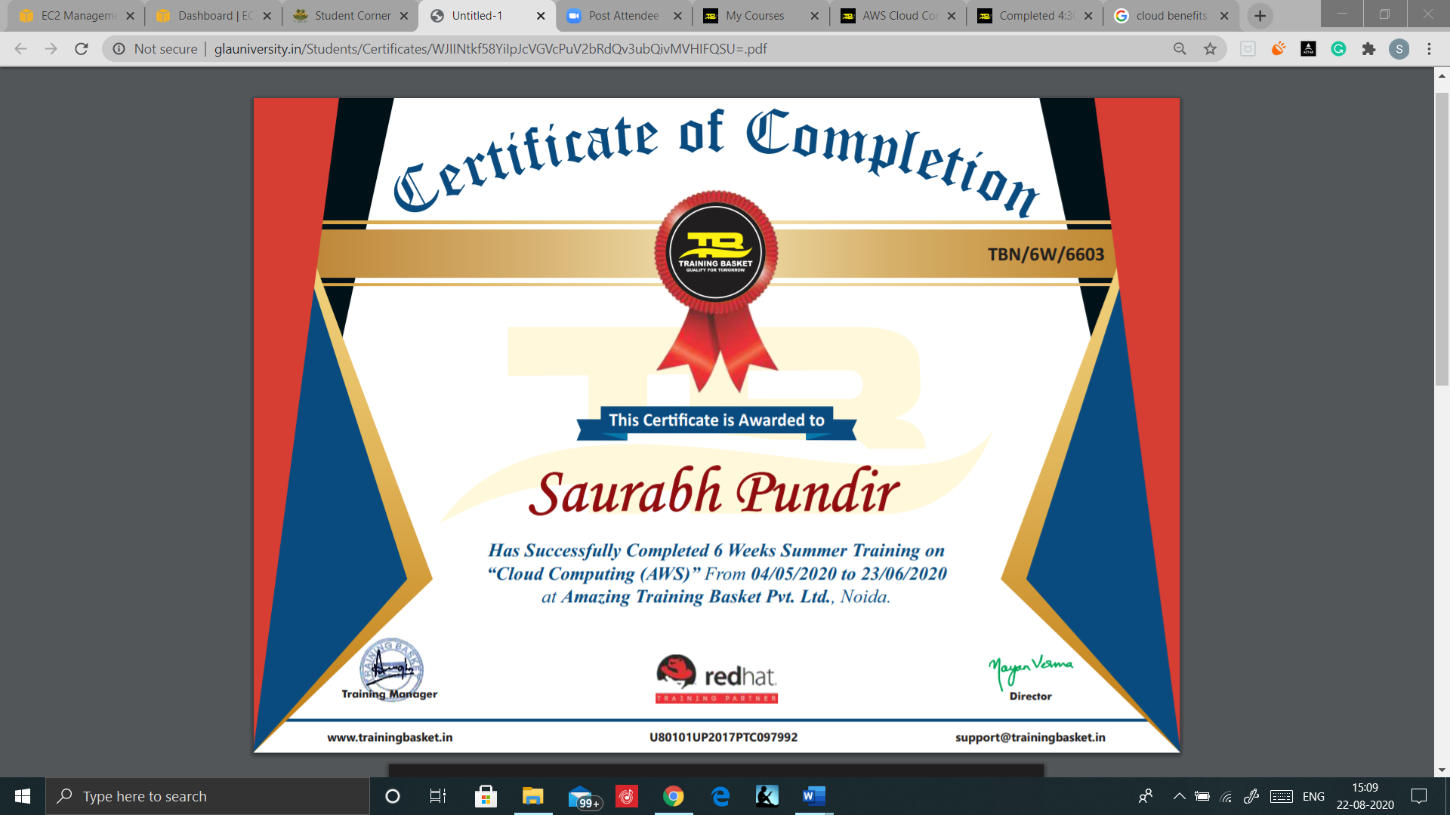

CERTIFICATE



Student Information:

|  |  |
| --- | --- |
| Name: SAURABH PUNDIR | University Roll. No.: 181510028 |
| Mobile: 9719477264 | Email: pundirsaurabh2000@gmail.com |

Information about Industry/Organization:

|  |  |
| --- | --- |
| Industry/Organization Name with full Address | AMAZING TRAINING BASKET PVT LTD  A-40, 2 floor, Unit NO. 207, IT Thum tower, Sector-2, Noida |
| Contact Person | Name & Designation: DIVYA  Mobile/email: 9354921086/ divya@trainingbasket.in |

Project Information:

|  |  |
| --- | --- |
| Title Of Project/Training/Task | “LOAD BALANCED AND AUTO SCALED ARCHITECTURE” |
| Technical Details | Hardware Requirements: Laptop  Software Requirements: Browser |
| Training Implementation Details | Fully Implemented |
| Training Period | Start Date: 04 MAY, 2020  End Date: 23 JUN, 2020  Duration Of Training (In Weeks): 6 Weeks |

Summary of the Training Work:

|  |
| --- |
| This training of AWS has enabled me to learn lot a many services from it. AWS consists of many services in various domains. This project includes the use of one of the major services of AWS i.e. EC2 (Elastic Compute Cloud). Here we are creating an application architecture which is fault tolerant, highly available, efficient, and flexible. We will create an EC2 Instance with IIS server installed on it and EBS volume configured. Then we will create an Application Load Balancer to Load the Balances of Incoming user requests or calls. Later we will configure the Load Balancer with Auto Scaling that will Scaled up or Scaled down the resources as per requirement or need or no. of requests that are applications are receiving.  Hence the combination of Load Balancer and Auto scaling will create our Infrastructure Fault tolerant, highly available. |

ACKNOWLEDGEMENT

The success and final outcome of this project required a lot of guidance and assistance from many people and I am extremely privileged to have got this all along the completion of my project. All that I have done is only due to such supervision and assistance and I would not forget to thank them.

I respect and thank **Mr. Arun Ojha**, for providing me an opportunity to do the project work in **AWS** and giving me support and guidance, which made me complete the project duly. I am extremely thankful to him for providing such a nice support and guidance, although he had busy schedule managing the corporate affairs.

I owe my deep gratitude to my team members, who took keen interest on our project work, till the completion of this project work by providing all the necessary information for developing a good system.

I am thankful to and fortunate enough to get constant encouragement, support and guidance from all Teaching staffs of which helped us in successfully completing our project work.

Thanks

SAURABH PUNDIR

(181510028)

ABSTRACT

This training of AWS has enabled me to learn lot a many services from it. AWS consists of many services in various domains. This project includes the use of one of the major services of AWS i.e. EC2 (Elastic Compute Cloud). Here we are creating an application architecture which is fault tolerant, highly available, efficient, and flexible. We will create an EC2 Instance with IIS server installed on it and EBS volume configured. Then we will create an Application Load Balancer to Load the Balances of Incoming user requests or calls. Later we will configure the Load Balancer with Auto Scaling that will Scaled up or Scaled down the resources as per requirement or need or no. of requests that are applications are receiving.

Hence the combination of Load Balancer and Auto scaling will create our Infrastructure Fault tolerant, highly available.

Department of computer Engineering and Applications

GLA University, Mathura

17 km. Stone NH#2, Mathura-Delhi Road, P.O. – Chaumuha,

Mathura – 281406



Declaration

I hereby declare that the work which is being presented in the Industrial Training “Load Balanced and Auto Scaled Architecture”, in partial fulfillment of the requirements for Industrial Training viva voce, is an authentic record of my own work carried under the supervision of “AMAZING TRAINING BASKET PVT. LTD”

Signature of Candidate:

Name of Candidate: SAURABH PUNDIR

Roll. No.: 181510028

Course: B.tech(CCV)

Year: III

Semester: V

Contents

1 What is AMAZON WEB SERVICES? 8

1.1 AWS Global Infrastructure Map 8

1.2 AWS Offers 8

2 EC2- ELASTIC COMPUTE CLOUD 9

2.1 Features of Amazon EC2 9

2.2 Amazon EC2 basic infrastructure 10

2.2.1 Amazon Machine Images and instances 10

2.2.2 Regions and Zones 10

2.2.3 Storage 11

2.2.4 Networking and security 12

3 ELASTIC LOAD BALANCING 13

3.1 Load balancer benefits 13

3.2 Features of Elastic Load Balancing 14

3.3 Types of Load Balancers 14

**3.3.1** Application Load Balancer. 15

3.3.2 Network Load Balancer 15

3.3.3 Classic Load Balancer 16

3.4 How Elastic Load Balancing works 16

3.4.1 Cross-zone load balancing 17

4 EC2 AUTO SCALING 18

4.1 Goal of Auto Scaling 19

4.2 Benefits of Auto Scaling 19

4.3 Instance lifecycle 20

4.4 Auto Scaling components 20

4.4.1 Groups 21

4.4.2 Configurations Templates 22

4.4.3 Scaling options 23

4.5 Scaling cooldowns 24

5 TUTORIAL 25

5.1 Create an Amazon EC2 Instance 25

5.2 Create a new Volume EBS disk 26

5.3 Launch EC2 instance. 27

5.3.1 Make your EBS disk available to use 28

5.4 Installation of IIS web server 29

5.5 Creation of AMI 31

5.6 Creation of Load Balancer 33

5.7 Create Auto Scaling 35

5.7.1 Create or select a Launch Configuration 35

5.7.2 Create Auto Scaling Group 36

6 TESTING 38

7 TERMINATING THE ENVIRONMENT 41

# What is AMAZON WEB SERVICES?

* AMAZON WEB SERVICES(AWS) is a collection of remote computing web services that together make up a cloud computing platform, offered over the internet by AMAZON.
* The AWS Global Cloud Infrastructure is the most secure, extensive, and reliable cloud platform, offering over 175 fully featured services from data centers globally. Whether you need to deploy your application workloads across the globe in a single click, or you want to build and deploy specific applications closer to your end-users with single-digit millisecond latency, AWS provides you the cloud infrastructure where and when you need it.

## AWS Global Infrastructure Map

AWS now spans 77 Availability Zones within 24 geographic regions around the world, and has announced plans for nine more Availability Zones and three more AWS Regions in Indonesia, Japan, and Spain.

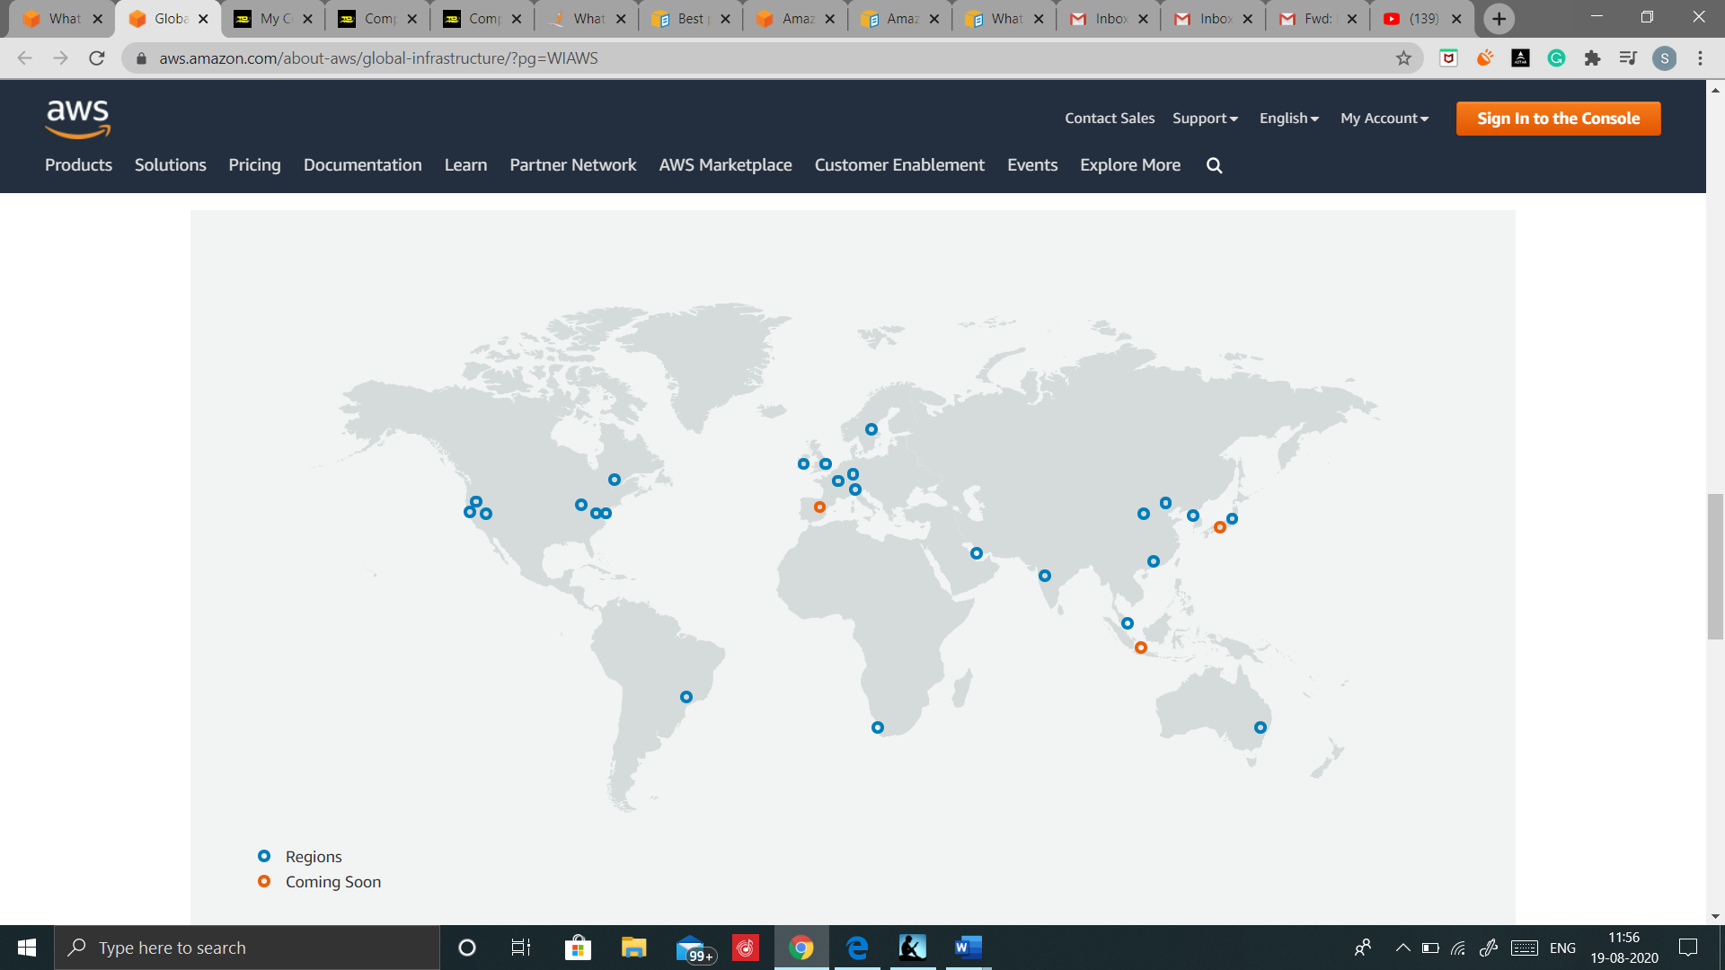

## AWS Offers

* Pay-As-You-Go pricing.
* Instant Elasticity & Scalability.
* Speed & Agility.
* Global Reach.
* Open & flexible.
* Secure.

# EC2- ELASTIC COMPUTE CLOUD

* Amazon Elastic Compute Cloud (Amazon EC2) provides scalable computing capacity in the Amazon Web Services (AWS) cloud.
* Using Amazon EC2 eliminates your need to invest in hardware up front, so you can develop and deploy applications faster.
* You can use Amazon EC2 to launch as many or as few virtual servers as you need, configure security and networking, and manage storage.
* Amazon EC2 enables you to scale up or down to handle changes in requirements or spikes in popularity, reducing your need to forecast traffic.

## Features of Amazon EC2

* Virtual computing environments, known as INSTANCES.
* Preconfigured templates for your instances, known as Amazon Machine Images (AMIs), that package the bits you need for your server (including the operating system and additional software).
* Various configurations of CPU, memory, storage, and networking capacity for your instances, known as Instance Types.
* Secure login information for your instances using key pairs (AWS stores the public key, and you store the private key in a secure place).
* Storage volumes for temporary data that's deleted when you stop or terminate your instance, known as instance store volumes.
* Persistent storage volumes for your data using Amazon Elastic Block Store (Amazon EBS), known as Amazon EBS volumes
* Multiple physical locations for your resources, such as instances and Amazon EBS volumes, known as Regions and Availability Zones.
* A firewall that enables you to specify the protocols, ports, and source IP ranges that can reach your instances using SECURITY GROUPS.
* Static IPv4 addresses for dynamic cloud computing, known as Elastic IP addresses
* Metadata, known as tags, that you can create and assign to your Amazon EC2 resources
* Virtual networks you can create that are logically isolated from the rest of the AWS cloud, and that you can optionally connect to your own network, known as virtual private clouds (VPCs).

## Amazon EC2 basic infrastructure

### Amazon Machine Images and instances

* An Amazon Machine Image (AMI) is a template that contains a software configuration (for example, an operating system, an application server, and applications).
* From an AMI, you launch instances, which are copies of the AMI running as virtual servers in the cloud.
* You can also create your own custom AMI.
* You can launch different types of instances from a single AMI.
* An instance type essentially determines the hardware of the host computer used for your instance. Each instance type offers different compute and memory facilities.

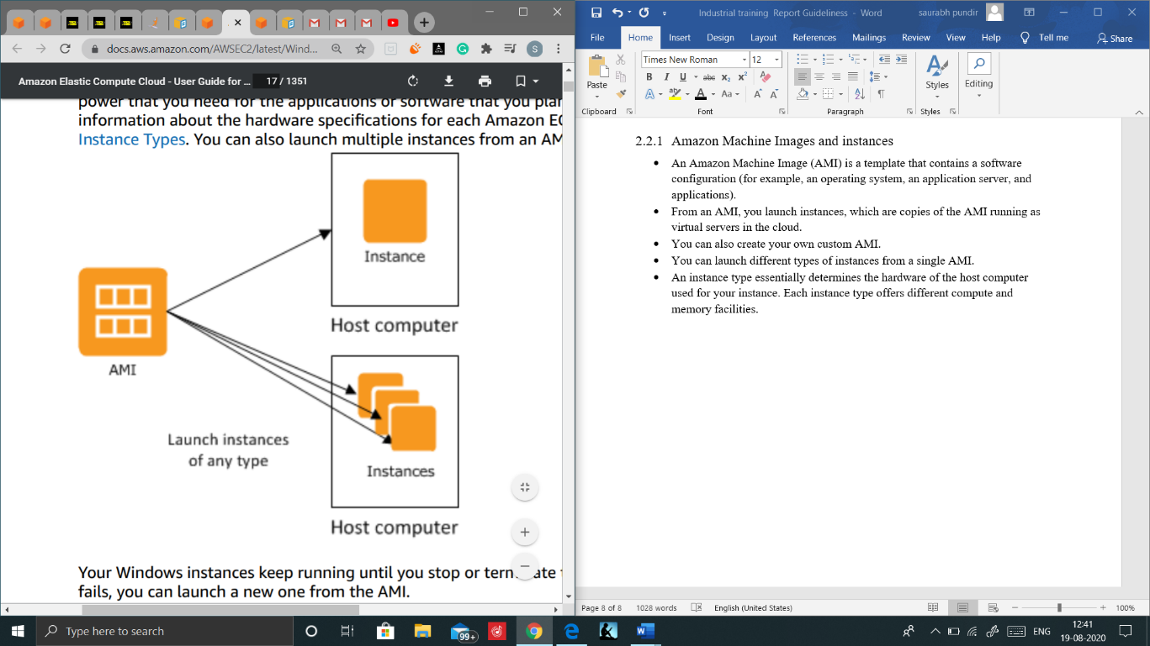

### Regions and Zones

Amazon EC2 is hosted in multiple locations world-wide. These locations are composed of Regions, Availability Zones, Local Zones, and Wavelength Zones. Each Region is a separate geographic area.

* Availability Zones are multiple, isolated locations within each Region.
* Local Zones provide you the ability to place resources, such as compute and storage, in multiple locations closer to your end users.
* AWS Outposts brings native AWS services, infrastructure, and operating models to virtually any data center, co-location space, or on-premises facility.
* Wavelength Zones allow developers to build applications that deliver ultra-low latencies to 5G devices and end users. Wavelength deploys standard AWS compute and storage services to the edge of telecommunication carriers' 5G networks.

### Storage

When using Amazon EC2, you may have data that you need to store.

The following figure shows the relationship between types of storage

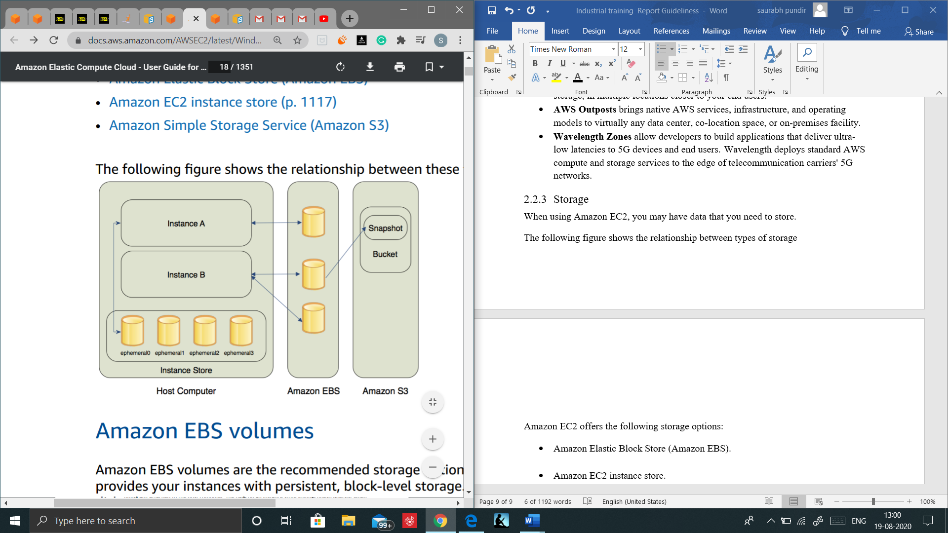

Amazon EC2 offers the following storage options:

* Amazon Elastic Block Store (Amazon EBS).

Amazon EBS provides your instances with persistent, block-level storage. Amazon EBS volumes are essentially hard disks that you can attach to a running instance

Amazon EBS is especially suited for applications that require a database, a file system, or access to raw block-level storage.

As illustrated in the previous figure, you can attach multiple volumes to an instance. Also, to keep a backup copy of your data, you can create a snapshot of an EBS volume, which is stored in Amazon S3. You can create a new Amazon EBS volume from a snapshot, and attach it to another instance. You can also detach a volume from an instance and attach it to a different instance.

The following figure illustrates the life cycle of an EBS volume.

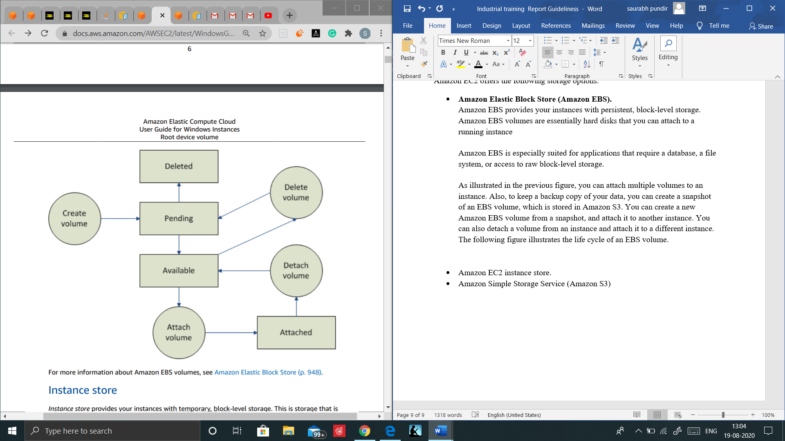

* Amazon EC2 instance store.

Instance store provides your instances with temporary, block-level storage. This is storage that is physically attached to the host computer.

The data on an instance store volume doesn't persist when the associated instance is stopped or terminated. For a list of instance store volumes available on each supported instance type, see Instance store volumes.

Instance store is an option for inexpensive temporary storage. You can use instance store volumes if you don't require data persistence.

* Amazon Simple Storage Service (Amazon S3)

Amazon S3 is storage for the Internet. It provides a simple web service interface that enables you to store and retrieve any amount of data from anywhere on the web.

* Root device volume

When you launch an instance, the root device volume contains the image used to boot the instance.

When you launch a Windows instance, a root EBS volume is created from an EBS snapshot and attached to the instance.

By default, the root volume is deleted when the instance terminates (the DeleteOnTermination attribute is true).

Using the console, you can change DeleteOnTermination when you launch an instance. To change this attribute for an existing instance, you must use the command line.

### Networking and security

* By default, an instance is assigned public IPv4 address only if it's launched into a default VPC. An instance that's launched into a nondefault VPC must be specifically assigned a public IPv4 address at launch, or you must modify your subnet's default public IPv4 addressing behavior.
* Instances can fail or terminate for reasons outside of your control. If one fails and you launch a replacement instance, the replacement has a different public IPv4 address than the original. However, if your application needs a static IPv4 address, Amazon EC2 offers Elastic IP addresses.
* You can use security groups to control who can access your instances. These are analogous to an inbound network firewall that enables you to specify the protocols, ports, and source IP ranges that are allowed to reach your instances. You can create multiple security groups and assign different rules to each group. You can then assign each instance to one or more security groups, and we use the rules to determine which traffic is allowed to reach the instance. You can configure a security group so that only specific IP addresses or specific security groups have access to the instance.

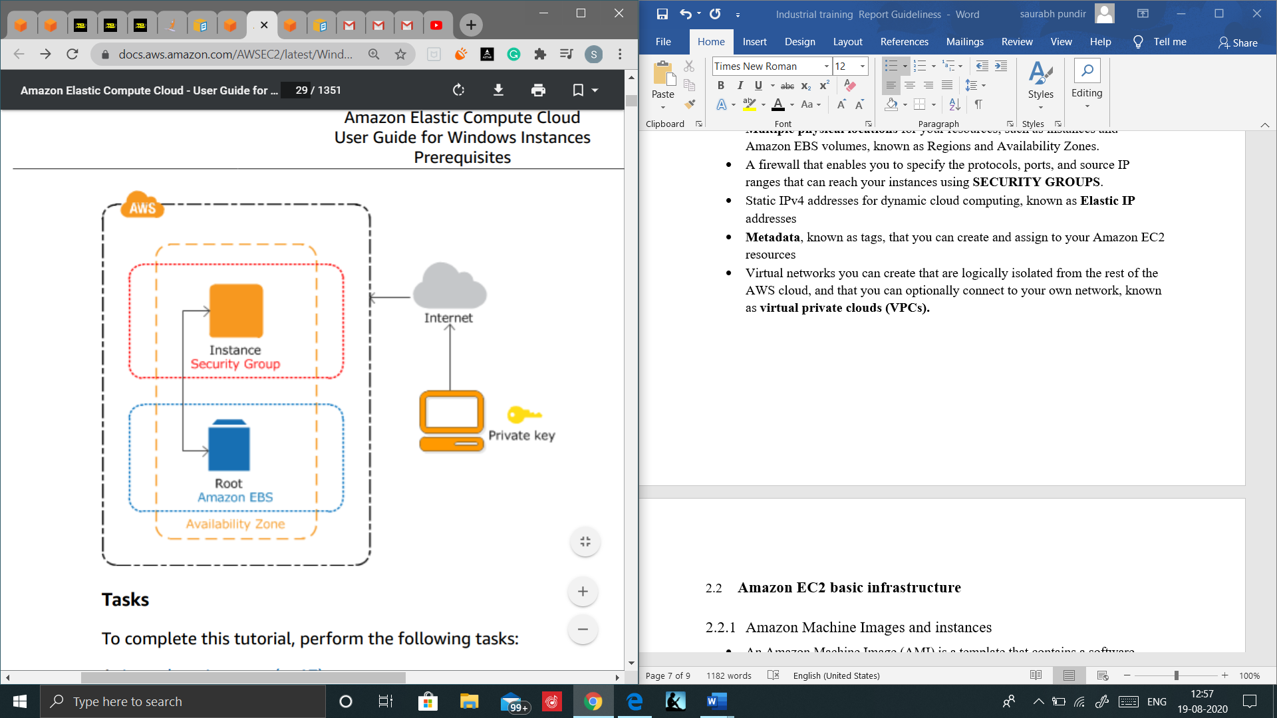

# ELASTIC LOAD BALANCING

Elastic Load Balancing distributes incoming application or network traffic across multiple targets, such as Amazon EC2 instances, containers, and IP addresses, in multiple Availability Zones. Elastic Load Balancing scales your load balancer as traffic to your application changes over time. It can automatically scale to the vast majority of workloads.

## Load balancer benefits

* A load balancer distributes workloads across multiple compute resources, such as virtual servers. Using a load balancer increases the availability and fault tolerance of your applications.
* You can add and remove compute resources from your load balancer as your needs change, without disrupting the overall flow of requests to your applications.
* You can configure health checks, which monitor the health of the compute resources, so that the load balancer sends requests only to the healthy ones. You can also offload the work of encryption and decryption to your load balancer so that your compute resources can focus on their main work.

## Features of Elastic Load Balancing

* High availability:

Elastic Load Balancing automatically distributes traffic across multiple targets – Amazon EC2 instances, containers and IP addresses – in a single Availability Zone or multiple Availability Zones.

* Health checks:

Elastic Load Balancing can detect unhealthy targets, stop sending traffic to them, and then spread the load across the remaining healthy targets.

* Security features:

Use Amazon Virtual Private Cloud (Amazon VPC) to create and manage security groups associated with load balancers to provide additional networking and security options. You can also create an internal (non-internet-facing) load balancer.

* TLS termination:

Elastic Load Balancing provides integrated certificate management and SSL/TLS decryption, allowing you the flexibility to centrally manage the SSL settings of the load balancer and offload CPU intensive work from your application.

* Layer 4 or Layer 7 load balancing:

You can load balance HTTP/HTTPS applications for layer 7-specific features, or use strict layer 4 load balancing for applications that rely on the TCP and UDP protocols.

* Operational monitoring:

Elastic Load Balancing provides integration with Amazon CloudWatch metrics and request tracing in order to monitor performance of your applications in real time.

## Types of Load Balancers

You can select the appropriate load balancer based on your application needs.

### Application Load Balancer.

* If you need flexible application management.
* Application Load Balancer is Layer 7(HTTP).
* Load balancing to multiple HTTP applications across machines (target groups).
* Support to HTTP/s and WebSocket.
* Routing to different target groups.
* Application Load Balancer are a great fit for micro services & container-based application (ex: Docker & Amazon ECS).
* Has a port mapping feature to redirect to a dynamic port in ECS.
* You are charged for each hour or partial hour that an Application Load Balancer is running and the number of Load Balancer Capacity Units (LCU) used per hour.

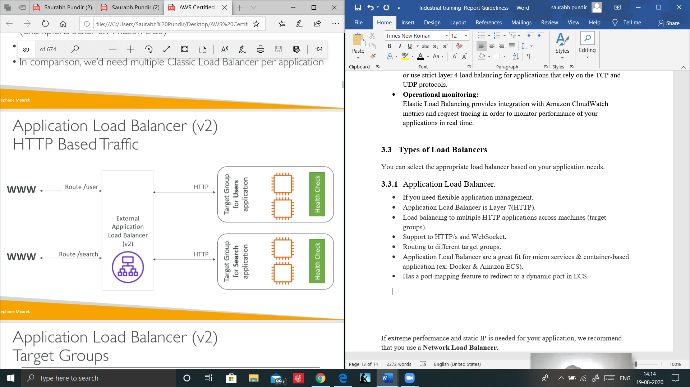

### Network Load Balancer

* If extreme performance and static IP is needed for your application.
* NLB is Layer 4(TCP & UDP).
* Forward TCP & UDP traffic to your instances.
* Handle millions pf request per seconds.
* Less latency as compared to ALB.
* NLB has one static IP per AZ and supports assigning Elastic IP.
* You are charged for each hour or partial hour that a Network Load Balancer is running and the number of Load Balancer Capacity Units (LCU) used by Network Load Balancer per hour.

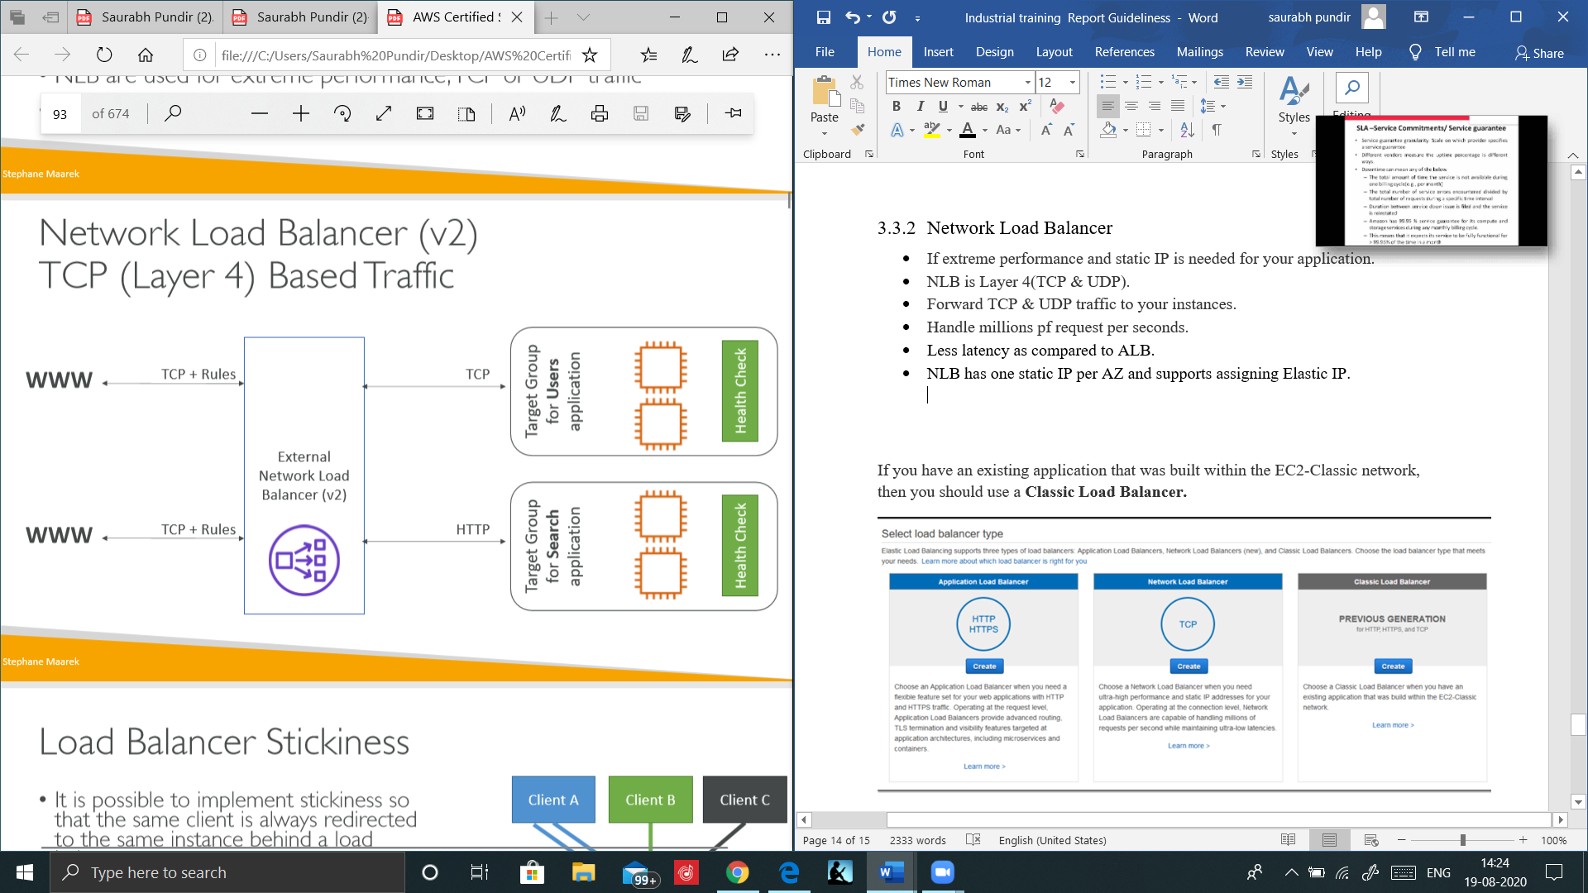

### Classic Load Balancer

* If you have an existing application that was built within the EC2-Classic network.
* Supports TCP (layer4), HTTP and HTTPS (layer7).
* Health checks are TCP or HTTP based.
* Fixed Hostname xxx.region.elb.amazonaws.com.
* You are charged for each hour or partial hour that a Classic Load Balancer is running and for each GB of data transferred through your load balancer.

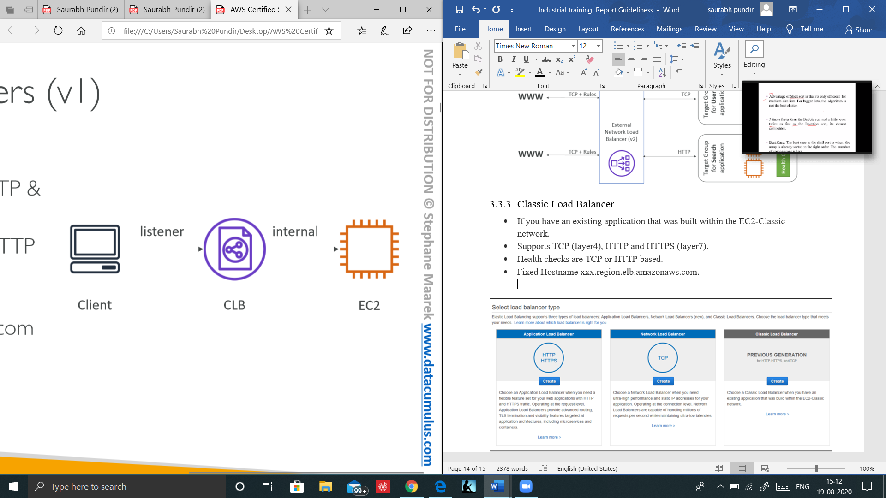

## How Elastic Load Balancing works

A load balancer accepts incoming traffic from clients and routes requests to its registered targets (such as EC2 instances) in one or more Availability Zones.

The load balancer also monitors the health of its registered targets and ensures that it routes traffic only to healthy targets. When the load balancer detects an unhealthy target, it stops routing traffic to that target. It then resumes routing traffic to that target when it detects that the target is healthy again.

You configure your load balancer to accept incoming traffic by specifying one or more listeners. A listener is a process that checks for connection requests. It is configured with a protocol and port number for connections from clients to the load balancer. Likewise, it is configured with a protocol and port number for connections from the load balancer to the targets.

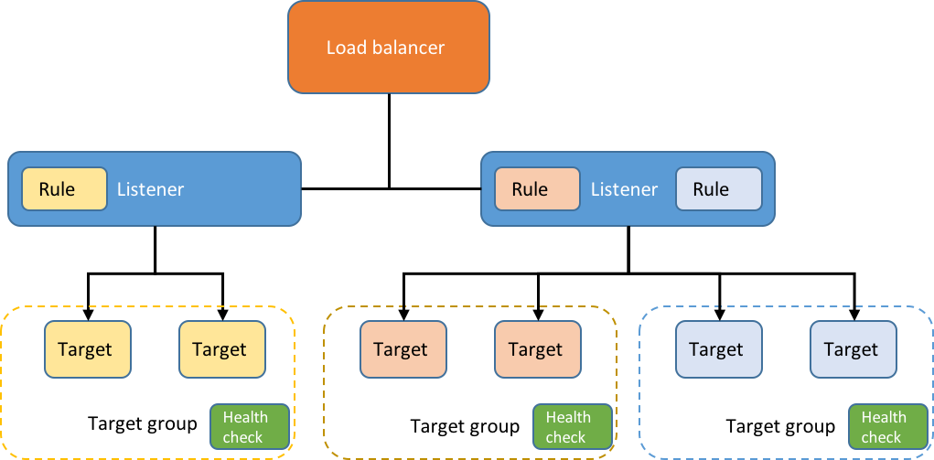

### Cross-zone load balancing

When cross-zone load balancing is enabled, each load balancer node distributes traffic across the registered targets in all enabled Availability Zones.

When cross-zone load balancing is disabled, each load balancer node distributes traffic only across the registered targets in its Availability Zone.

The following diagrams demonstrate the effect of cross-zone load balancing. There are two enabled Availability Zones, with two targets in Availability Zone A and eight targets in Availability Zone B. Clients send requests, and Amazon Route 53 responds to each request with the IP address of one of the load balancer nodes. This distributes traffic such that each load balancer node receives 50% of the traffic from the clients. Each load balancer node distributes its share of the traffic across the registered targets in its scope

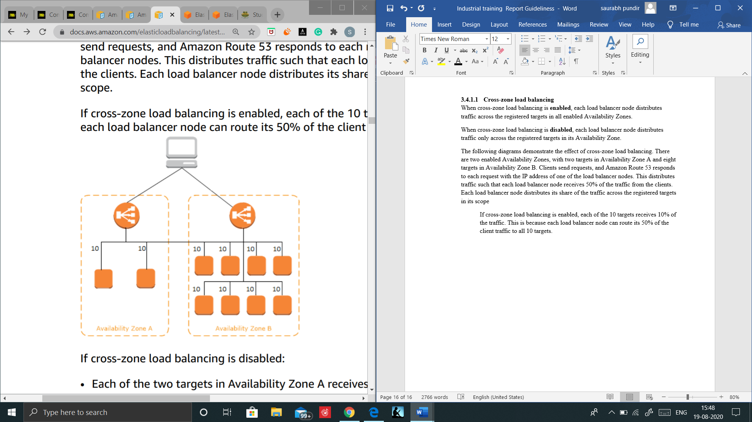

If cross-zone load balancing is enabled, each of the 10 targets receives 10% of the traffic. This is because each load balancer node can route its 50% of the client traffic to all 10 targets.

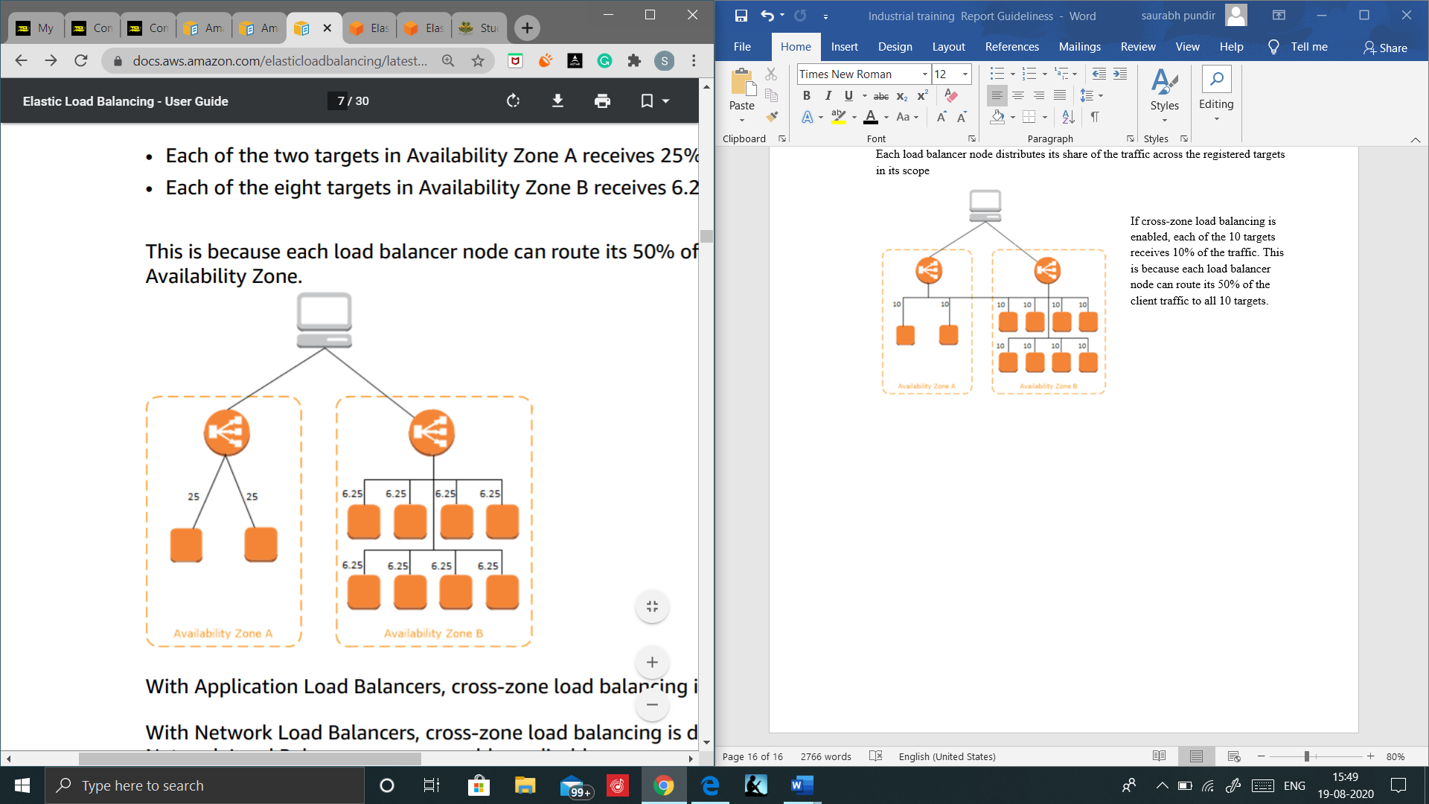

If cross-zone load balancing is disabled:

• Each of the two targets in Availability Zone A receives 25% of the traffic.

• Each of the eight targets in Availability Zone B receives 6.25% of the traffic.

This is because each load balancer node can route its 50% of the client traffic only to targets in its Availability Zone.

# EC2 AUTO SCALING

* Amazon EC2 Auto Scaling helps you ensure that you have the correct number of Amazon EC2 instances available to handle the load for your application. You create collections of EC2 instances, called Auto Scaling groups.
* You can specify the minimum number of instances in each Auto Scaling group, and Amazon EC2 Auto Scaling ensures that your group never goes below this size.
* You can specify the maximum number of instances in each Auto Scaling group, and Amazon EC2 Auto Scaling ensures that your group never goes above this size.
* If you specify the desired capacity, either when you create the group or at any time thereafter, Amazon EC2 Auto Scaling ensures that your group has many instances.
* If you specify scaling policies, then Amazon EC2 Auto Scaling can launch or terminate instances as demand on your application increases or decreases.

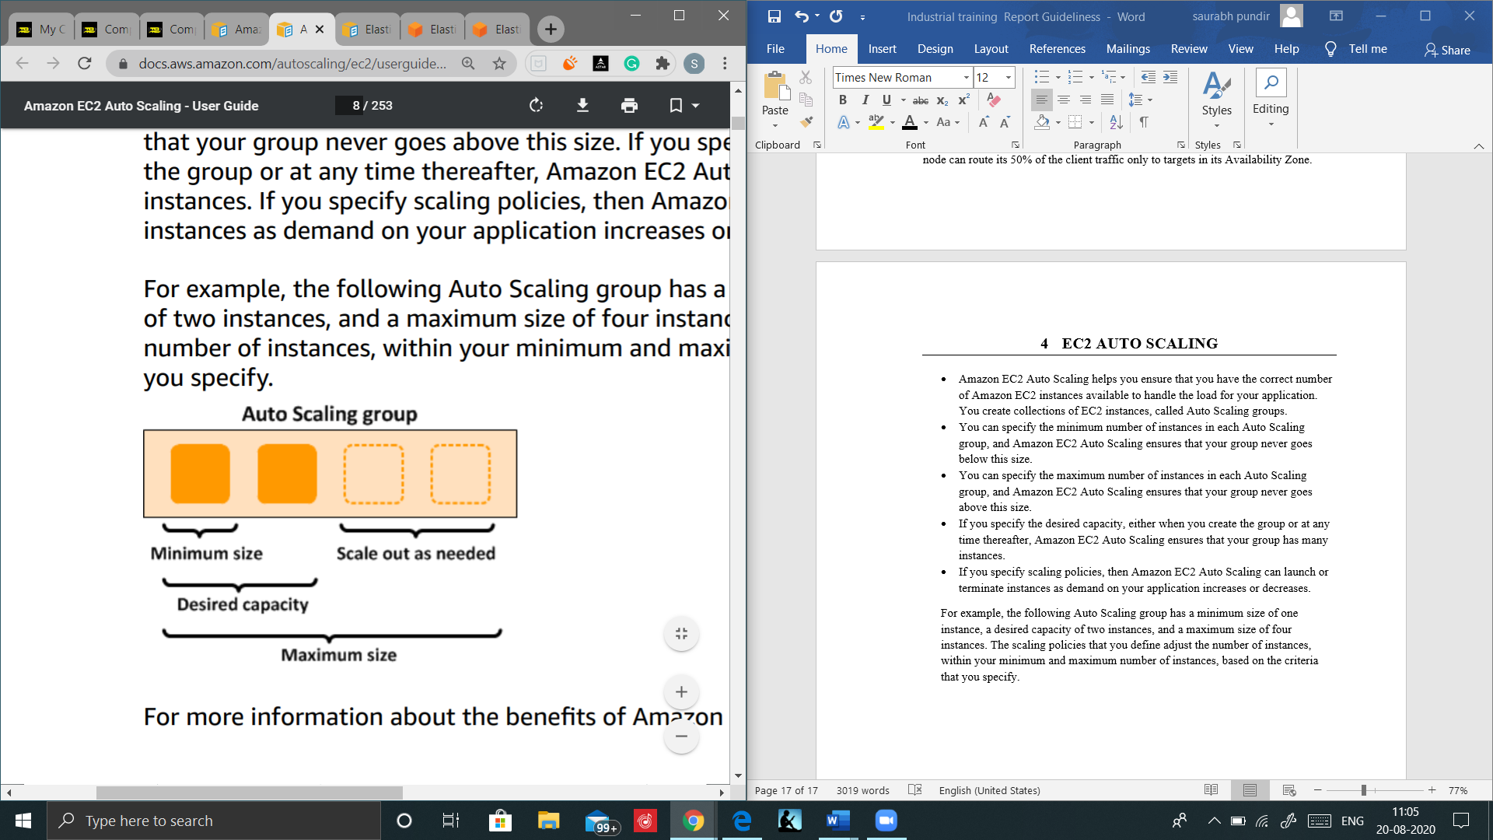For example, the following Auto Scaling group has a minimum size of one instance, a desired capacity of two instances, and a maximum size of four instances. The scaling policies that you define adjust the number of instances, within your minimum and maximum number of instances, based on the criteria that you specify.

* Pricing: There are no additional fees with Amazon EC2 Auto Scaling, so it's easy to try it out and see how it can benefit your AWS architecture.

## Goal of Auto Scaling

* Scale out (add EC2 instances) to match an increased load.
* Scale in (remove EC2 instances) to match a decreased load.
* Ensure we have a minimum and a maximum number of machines running.
* Automatically Register new instances to a load balance.

## Benefits of Auto Scaling

Adding Amazon EC2 Auto Scaling to your application architecture is one way to maximize the benefits of the AWS Cloud. When you use Amazon EC2 Auto Scaling, your applications gain the following benefits:

* Better fault tolerance. Amazon EC2 Auto Scaling can detect when an instance is unhealthy, terminate it, and launch an instance to replace it. You can also configure Amazon EC2 Auto Scaling to use multiple Availability Zones. If one Availability Zone becomes unavailable, Amazon EC2 Auto Scaling can launch instances in another one to compensate.
* Better availability. Amazon EC2 Auto Scaling helps ensure that your application always has the right amount of capacity to handle the current traffic demand.
* Better cost management. Amazon EC2 Auto Scaling can dynamically increase and decrease capacity as needed. Because you pay for the EC2 instances you use, you save money by launching instances when they are needed and terminating them when they aren't.

## Instance lifecycle

The EC2 instances in an Auto Scaling group have a path, or lifecycle, that differs from that of other EC2 instances.

The lifecycle starts when the Auto Scaling group launches an instance and puts it into service. The lifecycle ends when you terminate the instance, or the Auto Scaling group takes the instance out of service and terminates it.

Note You are billed for instances as soon as they are launched, including the time that they are not yet in service. The following illustration shows the transitions between instance states in the Amazon EC2 Auto Scaling lifecycle

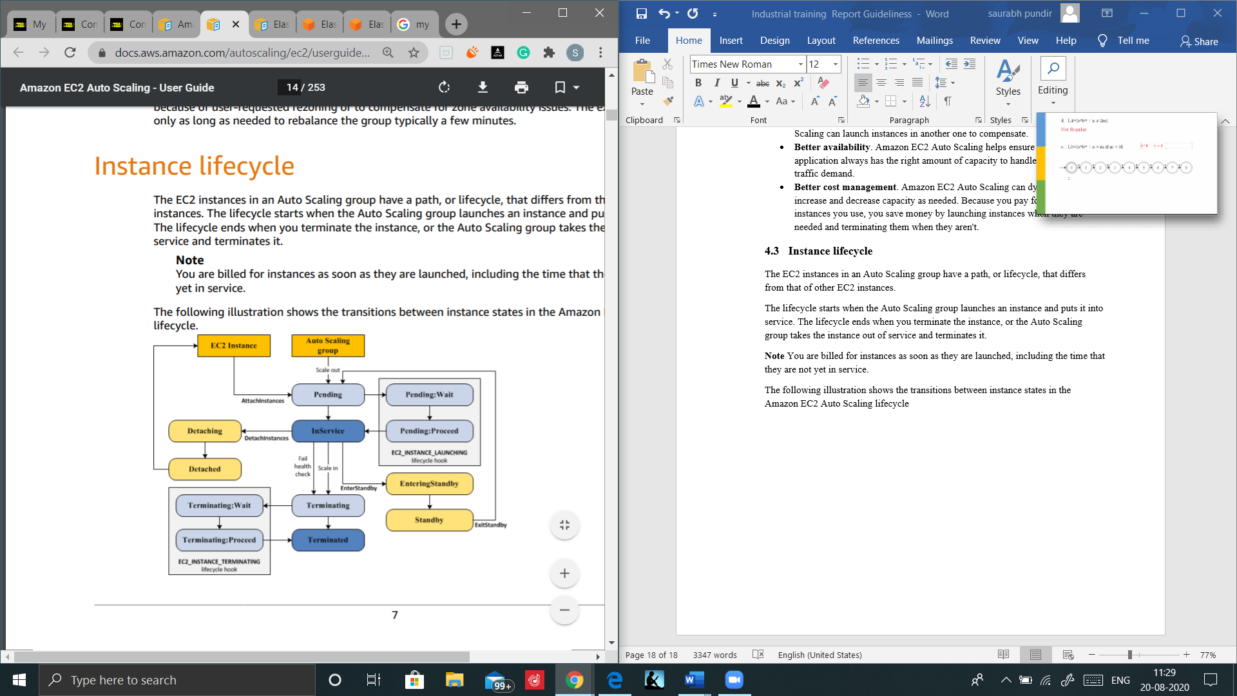

## Auto Scaling components

* Groups

Your EC2 instances are organized into groups so that they can be treated as a logical unit for the purposes of scaling and management. When you create a group, you can specify its minimum, maximum, and, desired number of EC2 instances.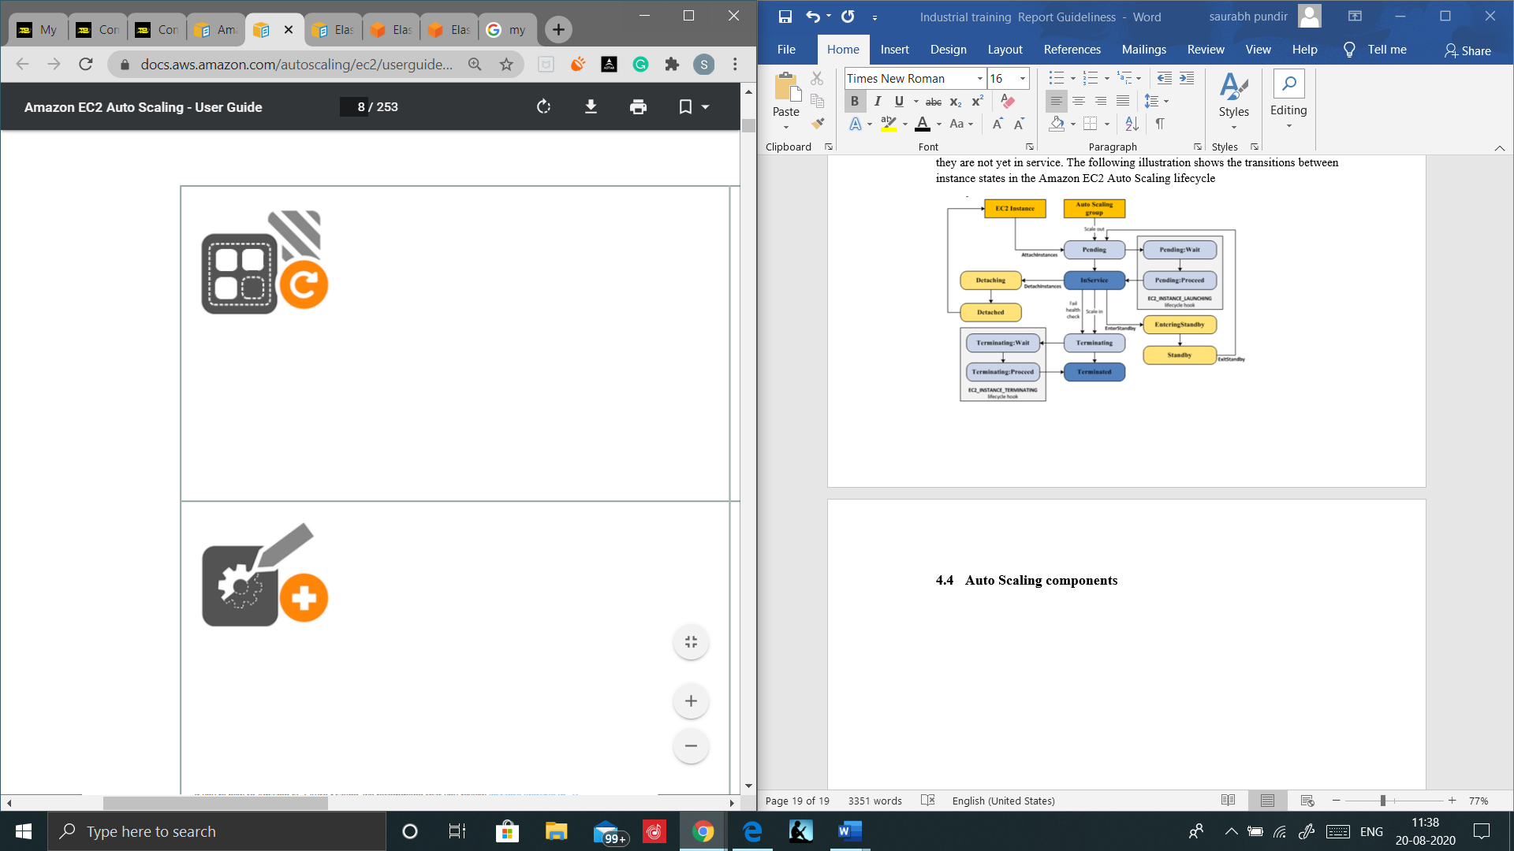

* Configuration templates

Your group uses a launch template or a launch configuration as a configuration template for its EC2 instances. You can specify information such as the AMI ID, instance type, key pair, security groups, and block device mapping for your instances.

* Scaling Options

Amazon EC2 Auto Scaling provides several ways for you to scale your Auto Scaling groups. For example, you can configure a group to scale based on the occurrence of specified conditions (dynamic scaling) or on a schedule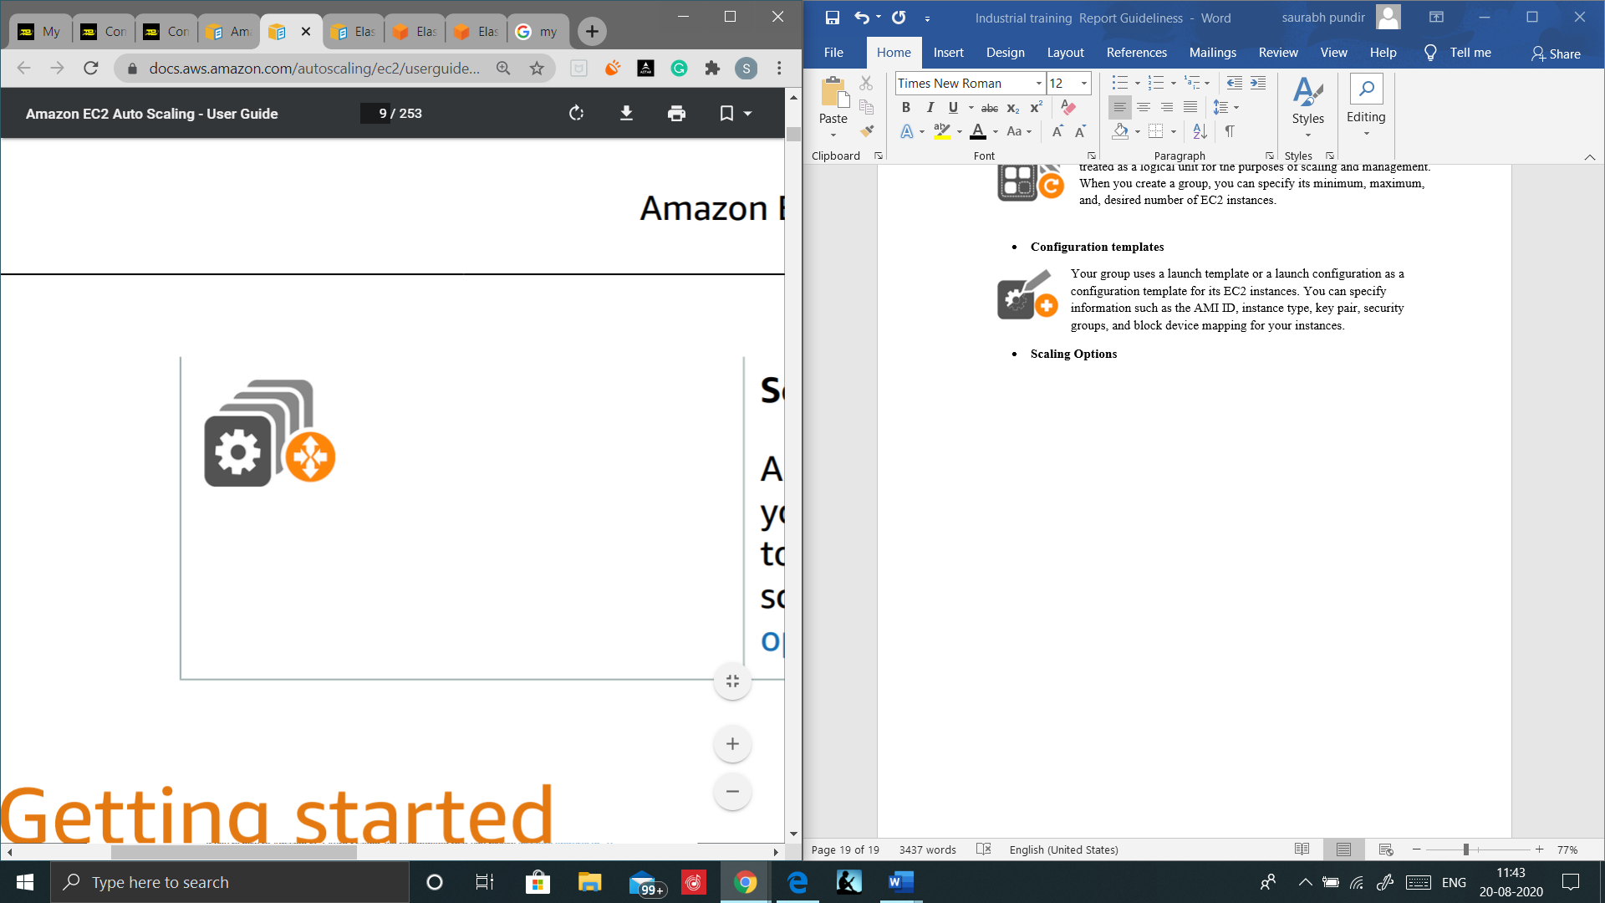.

### Groups

An Auto Scaling group contains a collection of Amazon EC2 instances that are treated as a logical grouping for the purposes of automatic scaling and management. An Auto Scaling group also enables you to use Amazon EC2 Auto Scaling features such as health check replacements and scaling policies. Both maintaining the number of instances in an Auto Scaling group and automatic scaling are the core functionality of the Amazon EC2 Auto Scaling service.

The size of an Auto Scaling group depends on the number of instances that you set as the desired capacity. You can adjust its size to meet demand, either manually or by using automatic scaling.

An Auto Scaling group starts by launching enough instances to meet its desired capacity. It maintains this number of instances by performing periodic health checks on the instances in the group. The Auto Scaling group continues to maintain a fixed number of instances even if an instance becomes unhealthy. If an instance becomes unhealthy, the group terminates the unhealthy instance and launches another instance to replace it.

You can use scaling policies to increase or decrease the number of instances in your group dynamically to meet changing conditions. When the scaling policy is in effect, the Auto Scaling group adjusts the desired capacity of the group, between the minimum and maximum capacity values that you specify, and launches or terminates the instances as needed. You can also scale on a schedule.

An Auto Scaling group can launch On-Demand Instances, Spot Instances, or both. You can specify multiple purchase options for your Auto Scaling group only when you configure the group to use a launch template. (We recommend that you use launch templates instead of launch configurations to make sure that you can use the latest features of Amazon EC2.)

When instances are launched, if you specified multiple Availability Zones, the desired capacity is distributed across these Availability Zones. If a scaling action occurs, Amazon EC2 Auto Scaling automatically maintains balance across all of the Availability Zones that you specify.

### Configurations Templates

A **launch configuration** is an instance configuration template that an Auto Scaling group uses to launch EC2 instances. When you create a launch configuration, you specify information for the instances. Include the ID of the Amazon Machine Image (AMI), the instance type, a key pair, one or more security groups, and a block device mapping. If you've launched an EC2 instance before, you specified the same information in order to launch the instance.

You can specify your launch configuration with multiple Auto Scaling groups. However, you can only specify one launch configuration for an Auto Scaling group at a time, and you can't modify a launch configuration after you've created it. To change the launch configuration for an Auto Scaling group, you must create a launch configuration and then update your Auto Scaling group with it.

Keep in mind that whenever you create an Auto Scaling group, you must specify a launch configuration, a launch template, or an EC2 instance. When you create an Auto Scaling group using an EC2 instance, Amazon EC2 Auto Scaling automatically creates a launch configuration for you and associates it with the Auto Scaling group.

Notes Alternatively, if you are using launch templates, you can specify a launch template instead of a launch configuration or an EC2 instance

#### Launch templates

Important We recommend that you create Auto Scaling groups from launch templates to ensure that you're getting the latest features from Amazon EC2.

A launch template is similar to a launch configuration, in that it specifies instance configuration information. Included are the ID of the Amazon Machine Image (AMI), the instance type, a key pair, security groups, and the other parameters that you use to launch EC2 instances. However, defining a launch template instead of a launch configuration allows you to have multiple versions of a template. With versioning, you can create a subset of the full set of parameters and then reuse it to create other templates or template versions. For example, you can create a default template that defines common configuration parameters and allow the other parameters to be specified as part of another version of the same template. If you plan to continue to use launch configurations with Amazon EC2 Auto Scaling, be aware that not all Auto Scaling group features are available. For example, you cannot create an Auto Scaling group that launches both Spot and On-Demand Instances or that specifies multiple instance types. You must use a launch template to configure these features.

In addition to the features of Amazon EC2 Auto Scaling that you can configure by using launch templates, launch templates provide more advanced Amazon EC2 configuration options

If you currently use launch configurations, you can specify a launch template when you update an Auto Scaling group that was created using a launch configuration.

### Scaling options

Amazon EC2 Auto Scaling provides several ways for you to scale your Auto Scaling group.

Maintain current instance levels at all times You can configure your Auto Scaling group to maintain a specified number of running instances at all times. To maintain the current instance levels, Amazon EC2 Auto Scaling performs a periodic health check on running instances within an Auto Scaling group. When Amazon EC2 Auto Scaling finds an unhealthy instance, it terminates that instance and launches a new one.

#### Scale manually

Manual scaling is the most basic way to scale your resources, where you specify only the change in the maximum, minimum, or desired capacity of your Auto Scaling group. Amazon EC2 Auto Scaling manages the process of creating or terminating instances to maintain the updated capacity.

#### Scale based on a schedule

Scaling by schedule means that scaling actions are performed automatically as a function of time and date. This is useful when you know exactly when to increase or decrease the number of instances in your group, simply because the need arises on a predictable schedule.

#### Scale based on demand

A more advanced way to scale your resources, using scaling policies, lets you define parameters that control the scaling process. For example, let's say that you have a web application that currently runs on two instances and you want the CPU utilization of the Auto Scaling group to stay at around 50 percent when the load on the application changes. This method is useful for scaling in response to changing conditions, when you don't know when those conditions will change. You can set up Amazon EC2 Auto Scaling to respond for you.

#### Use predictive scaling

You can also use Amazon EC2 Auto Scaling in combination with AWS Auto Scaling to scale resources across multiple services. AWS Auto Scaling can help you maintain optimal availability and performance by combining predictive scaling and dynamic scaling (proactive and reactive approaches, respectively) to scale your Amazon EC2 capacity faster.

## Scaling cooldowns

A scaling cooldown helps you prevent your Auto Scaling group from launching or terminating additional instances before the effects of previous activities are visible.

A default cooldown period automatically applies to any scaling activities for simple scaling policies, and you can optionally request to have it apply to your manual scaling activities. You can configure the length of time based on your instance startup time or other application needs.

When you use simple scaling, after the Auto Scaling group scales using a simple scaling policy, it waits for a cooldown period to complete before any further scaling activities due to simple scaling policies can start. An adequate cooldown period helps to prevent the initiation of an additional scaling activity based on stale metrics. By default, all simple scaling policies use the default cooldown period associated with your Auto Scaling group, but you can configure a different cooldown period for certain policies, as described in the following sections

During a cooldown period, when a scheduled action starts at the scheduled time, or when scaling activities due to target tracking or step scaling policies start, they can trigger a scaling activity immediately without waiting for the cooldown period to expire. If an instance becomes unhealthy, Amazon EC2 Auto Scaling also does not wait for the cooldown period to complete before replacing the unhealthy instance.

# TUTORIAL

## Create an Amazon EC2 Instance

Step1: Open Ec2 console <https://console.aws.amazon.com/ec2/>.

Step2: Click Launch Instance, and choose Microsoft Windows server 2019 base as Amazon Machine Image (AMI).

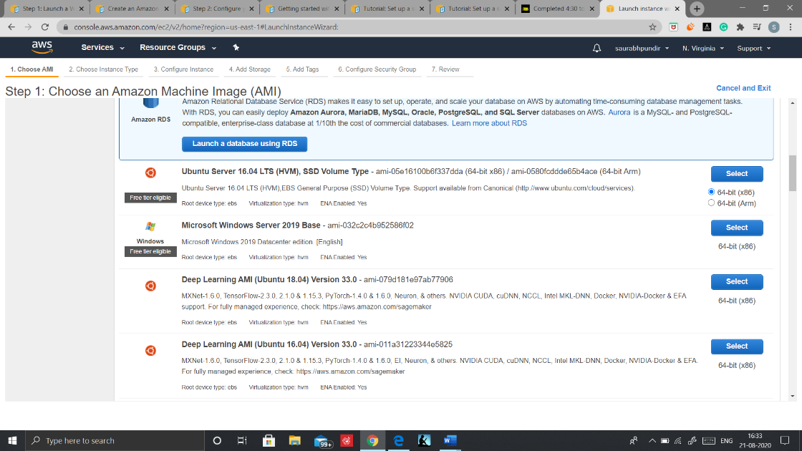

Step3: Choose an Instant type = t2.micro (Free tier eligible).

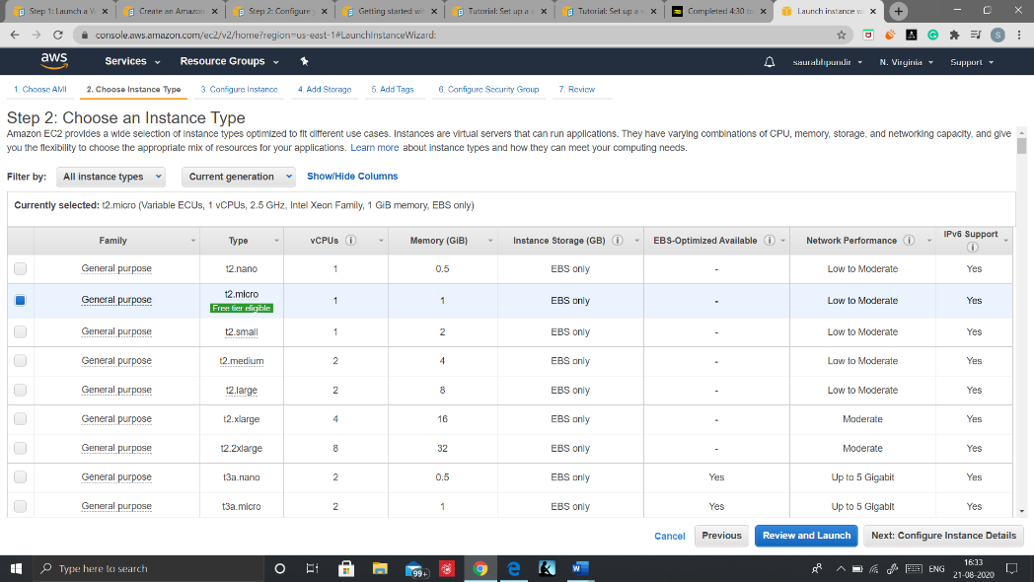

Step4: Configure your instance details (Leave everything as default), Click next and add Storage(default), Add Name tag “winvm”.

Step5: Configure Security group and configure the following protocols.

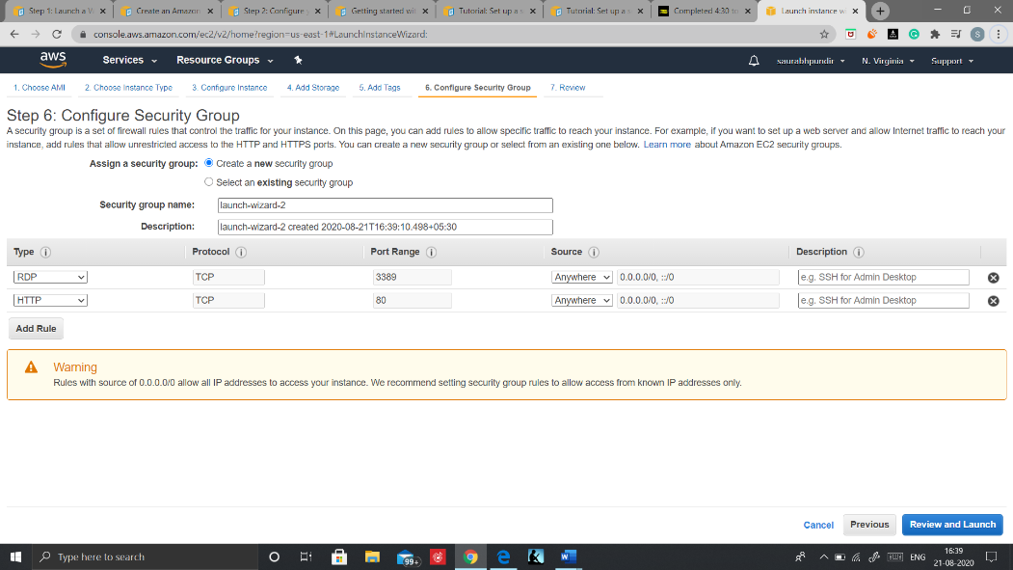

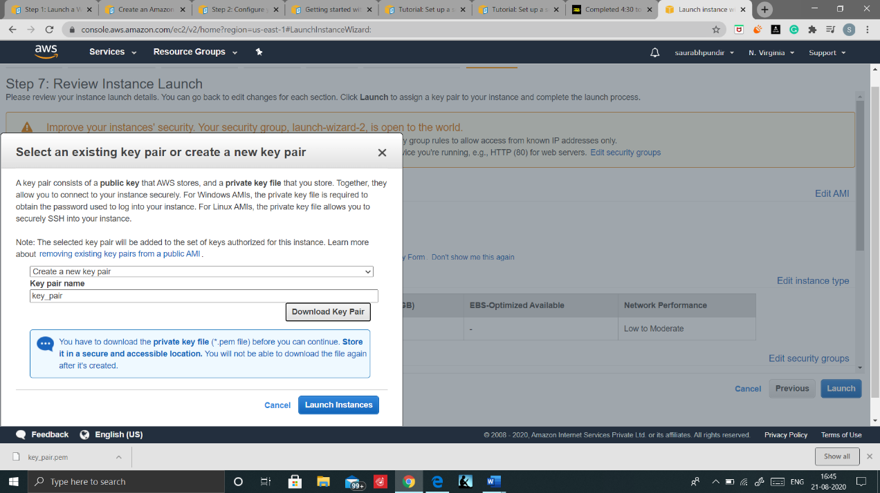

Step6: Review and launch, create a new key pair, download it, and Launch Instance.

## Create a new Volume EBS disk

Step1: In Ec2 console select Volume pane and click on create Volume.

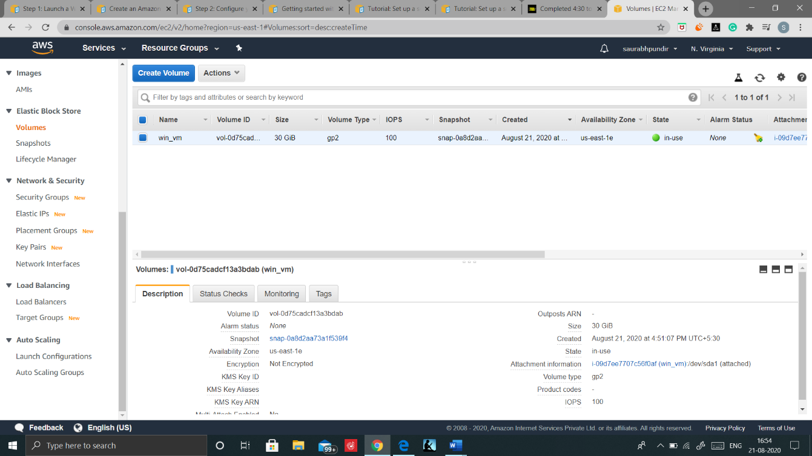

Step2: Select the same AZ’s here in which your instance is launched and create a name tag “win_ebs”

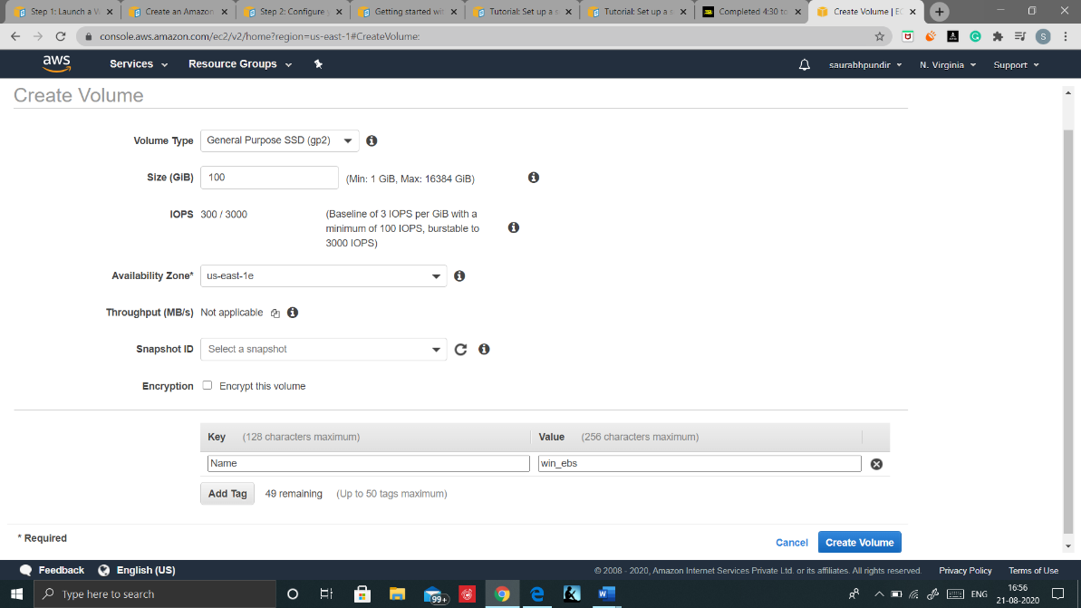

Step3: Attach your volume by clicking on Actions and then select attach volume, provide your instance details and click on attach

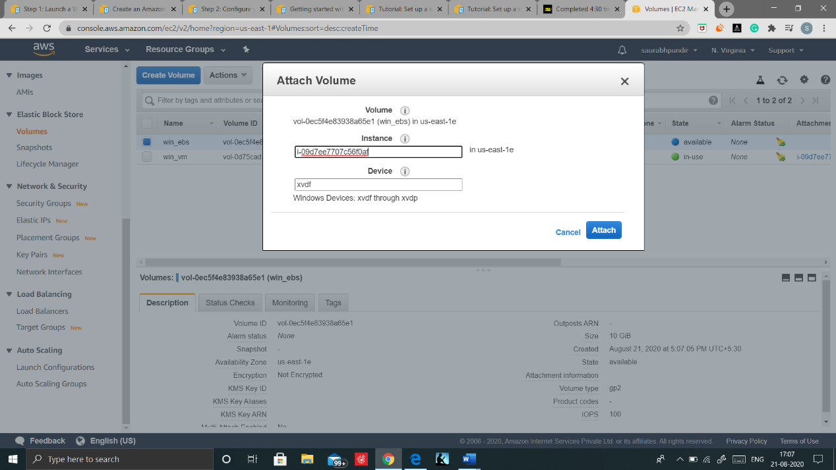

## Launch EC2 instance.

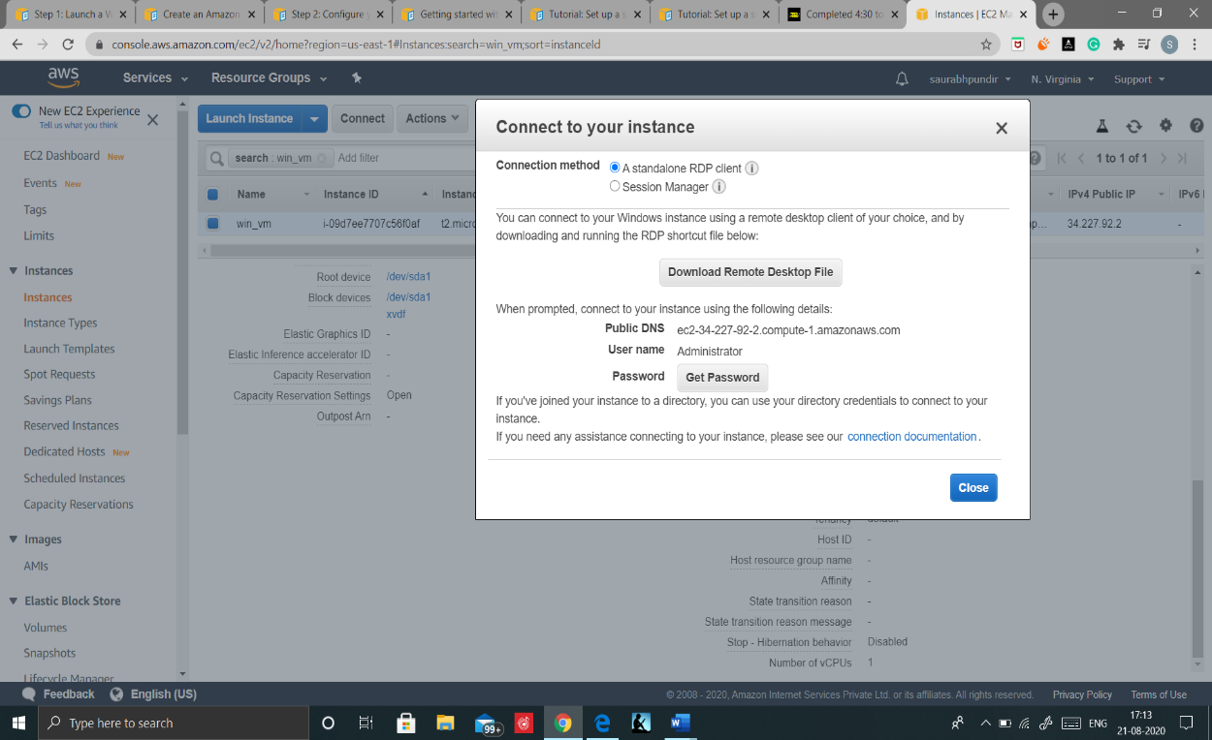

Step1: Select your Instance and click on connect

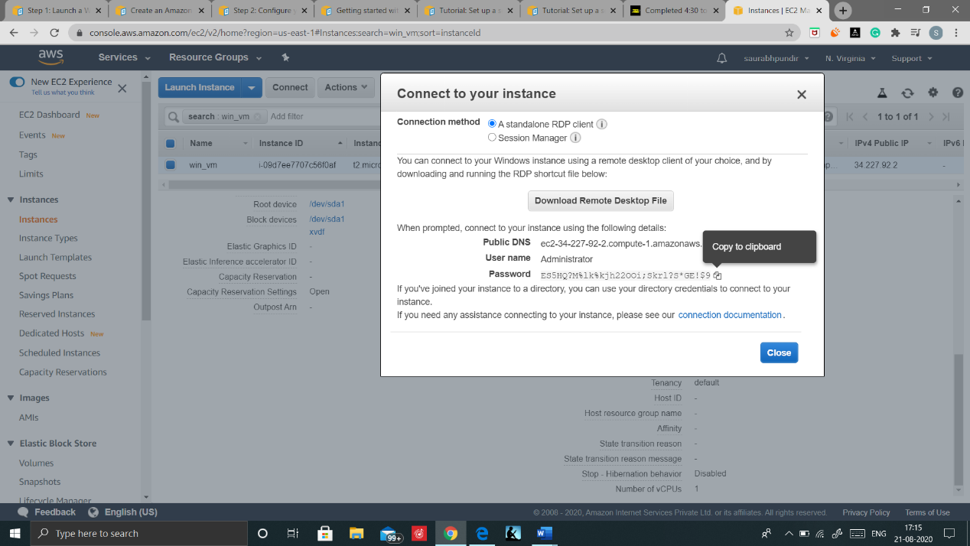

Step2: Click on get password and browse your downloaded key pair, select it and decrypt the password. Now copy the password. And Download the Remote Desktop File.

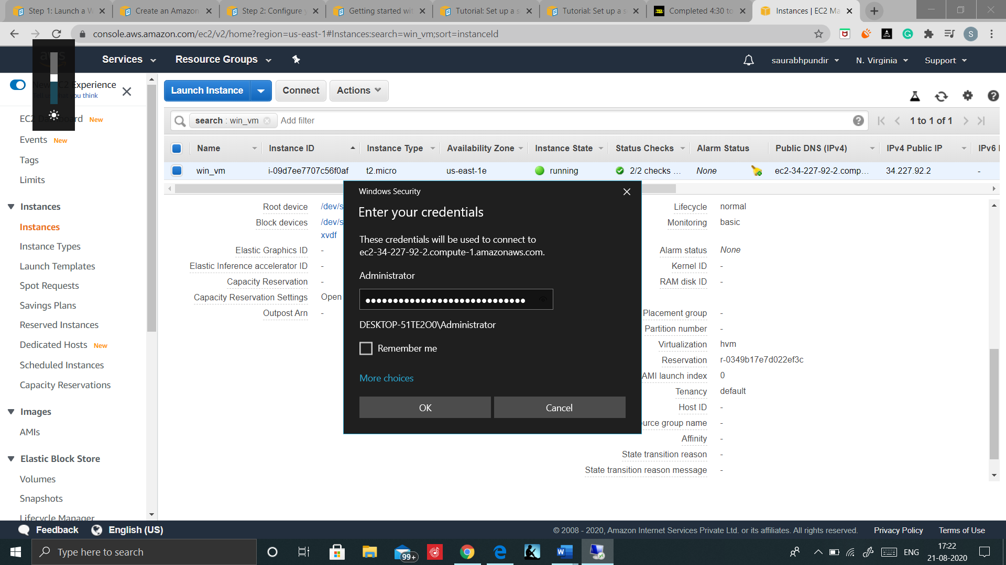

Step3: Open the downloaded Remote Desktop file, click on Connect and enter the Copied Password

Click on Ok, then yes and Your Instances is now launched.



### Make your EBS disk available to use

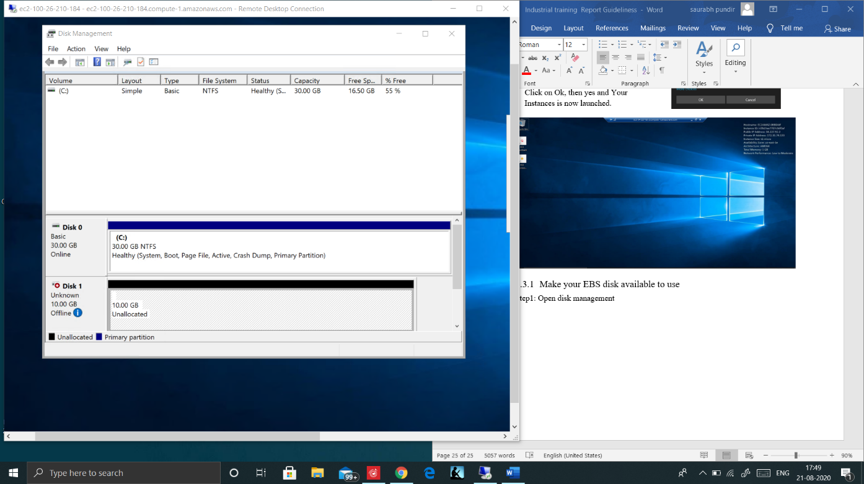

Step1: Open disk management, right click on disk1 and select online

Then Initialize the disk by right click on disk1 and your disk is now online.

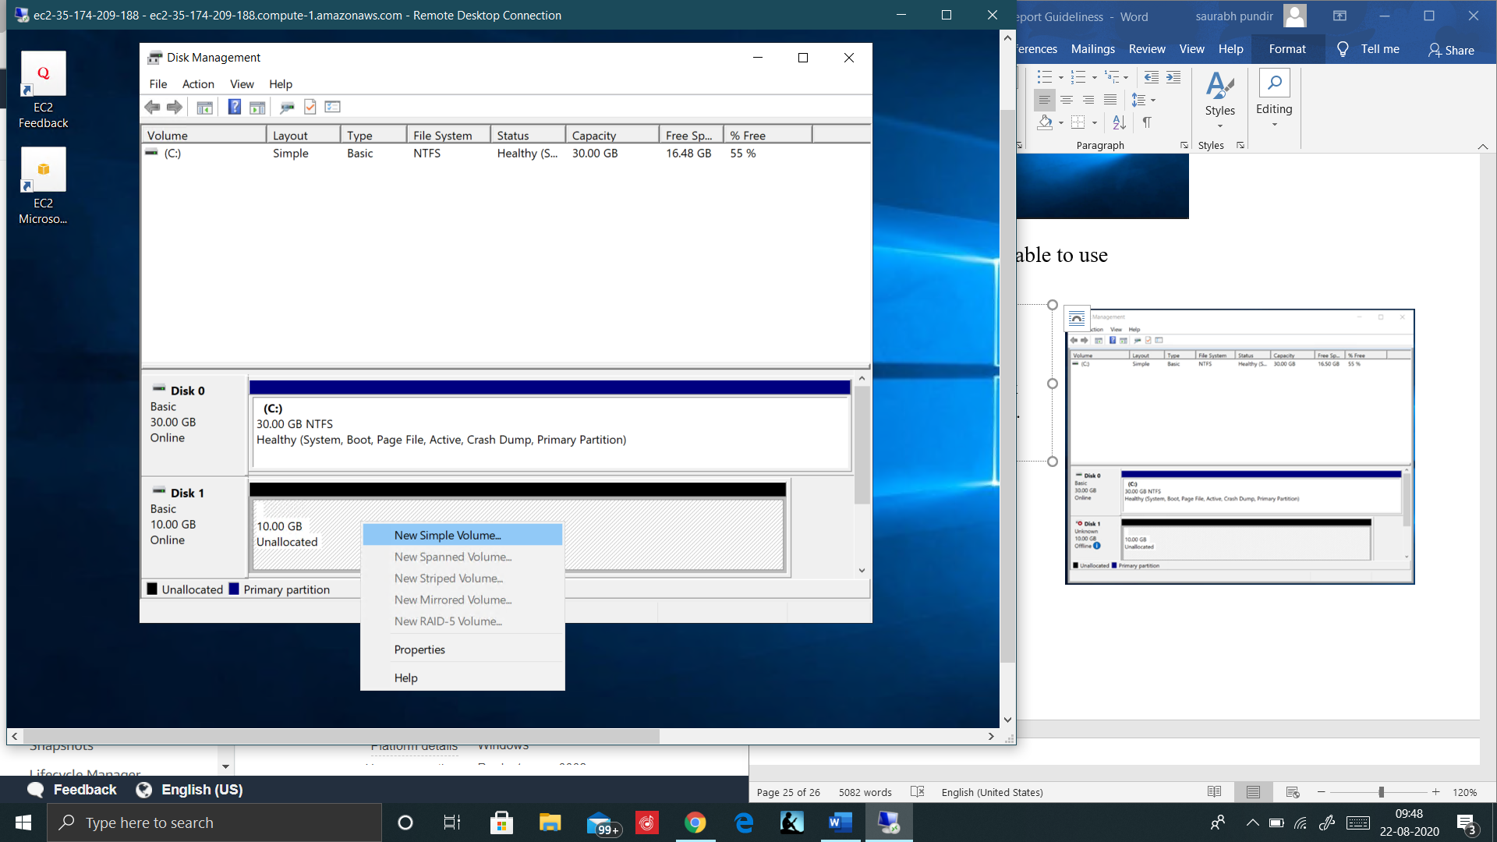

Step2: Right click on Disk tab and select New Simple Volume.

Complete the setup wizard and your disk is now available to use

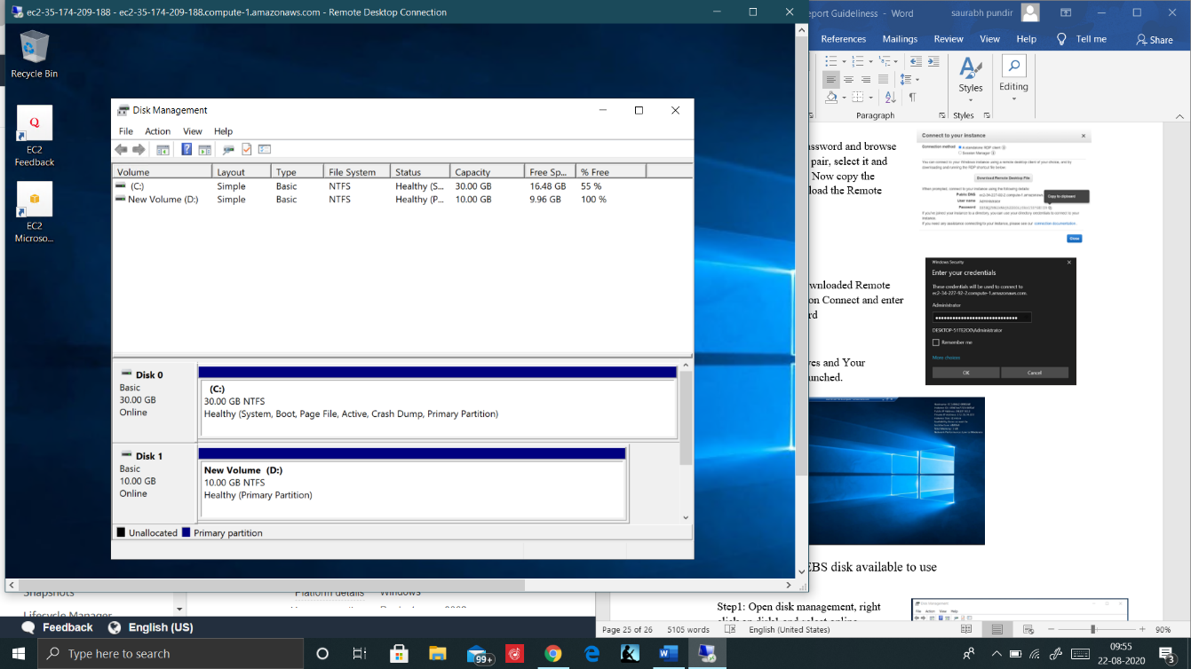

Your disk can be now visible in

MY PC

And you are good to go adding files in your drive

## Installation of IIS web server

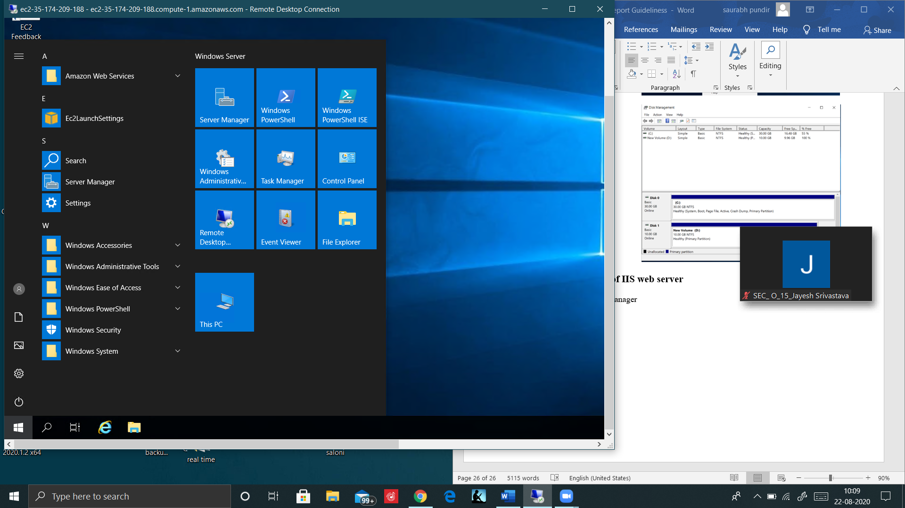

Step1: Search for Server Manager and Open it.

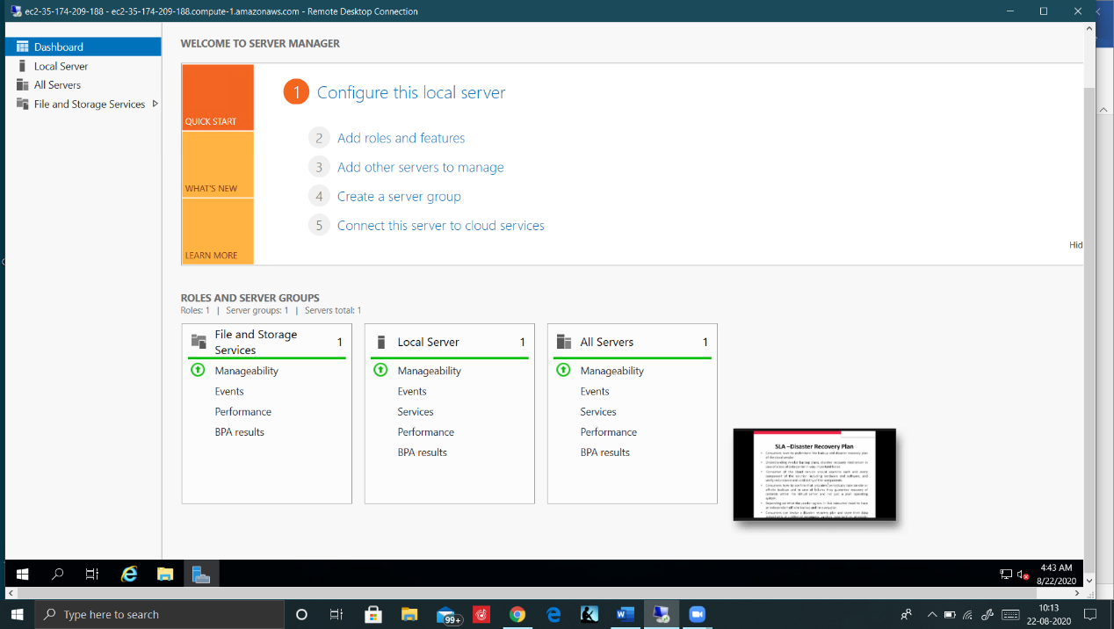

Step2: In Server Manager, click on ADD roles and Features

And Proceed with the default settings in Installation Wizard

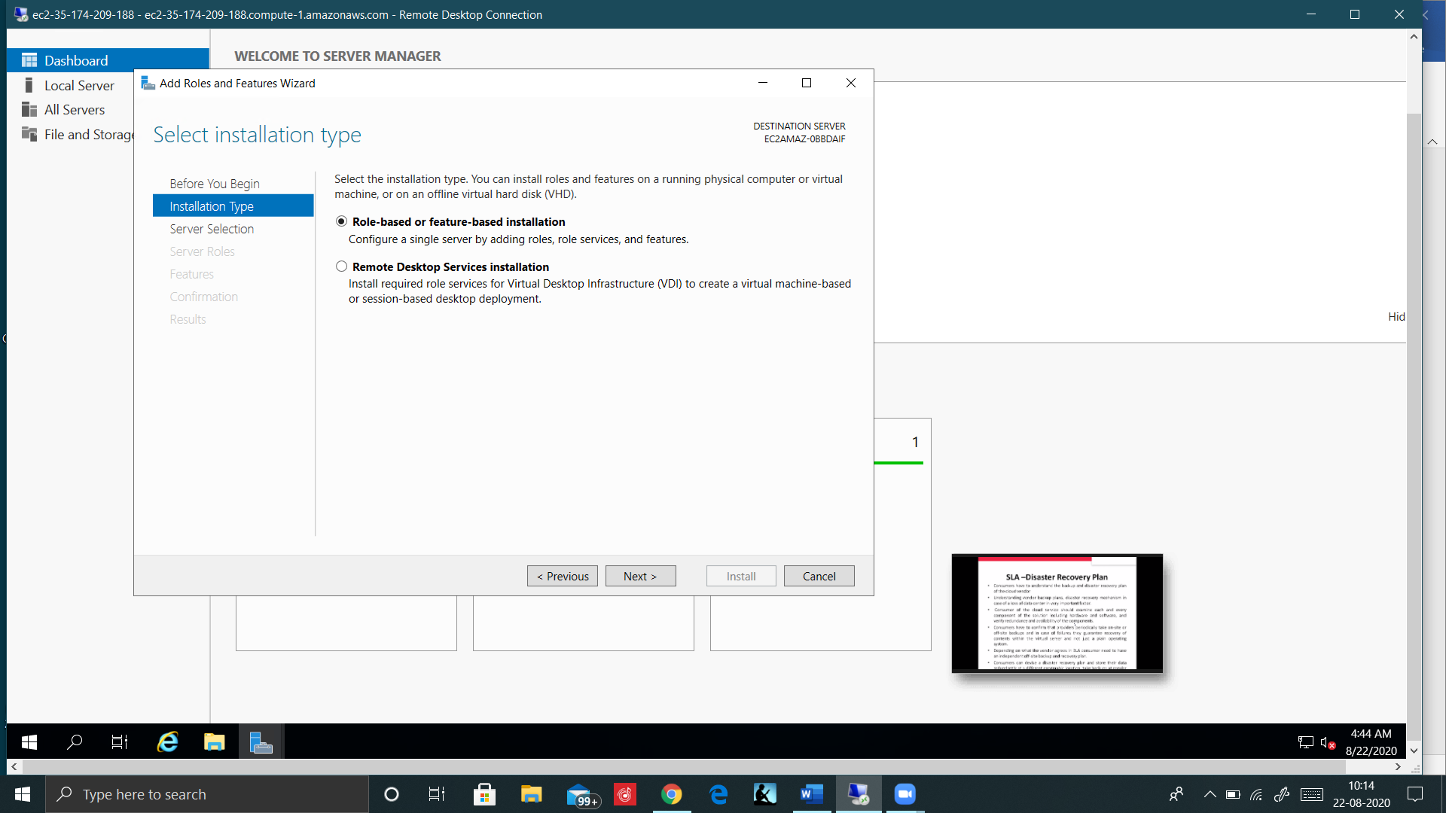

Step3: Select Role-Based installation type

And click on next

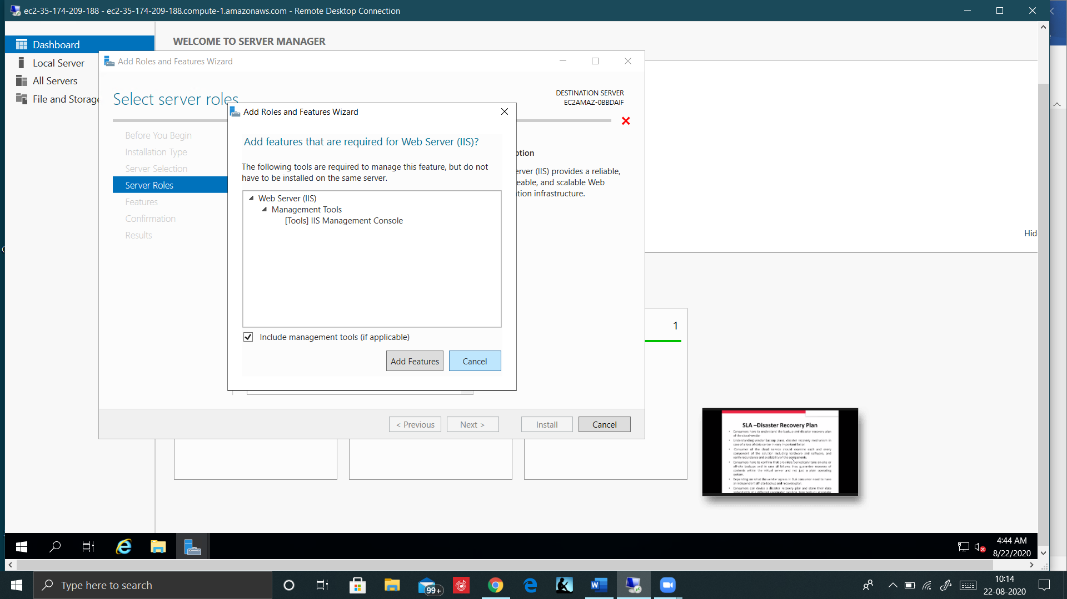

Step4: In Select server Role, Search for IIS web server, select it and click on add Features

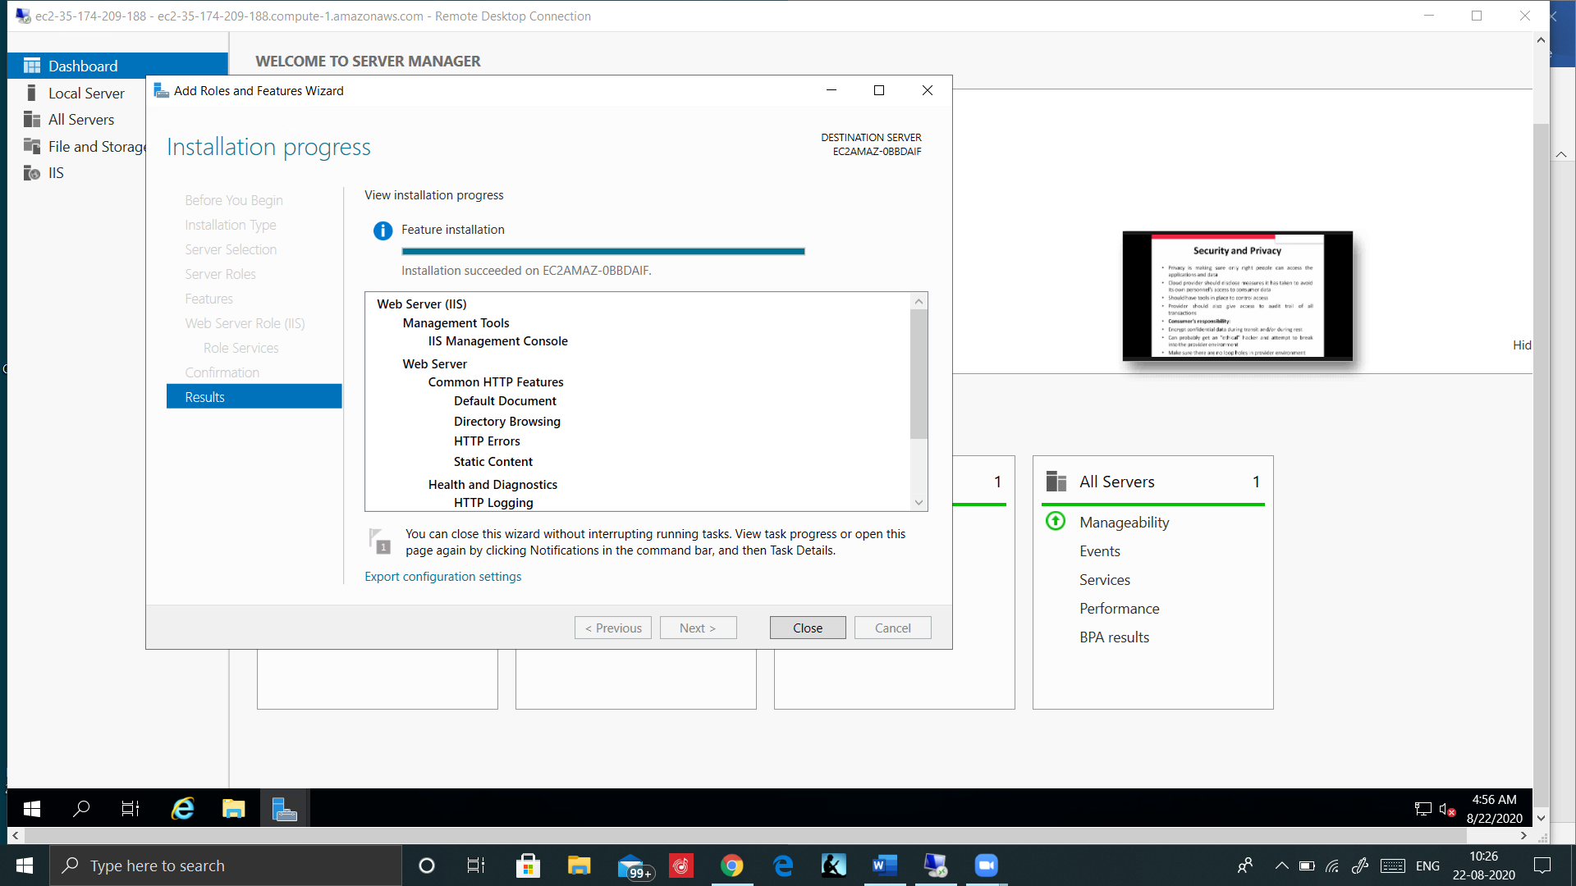

Installation COMPLETED!

Now Open your AWS console, Copy your PUBLIC IP or DNS and open it in new TAB in your web browser

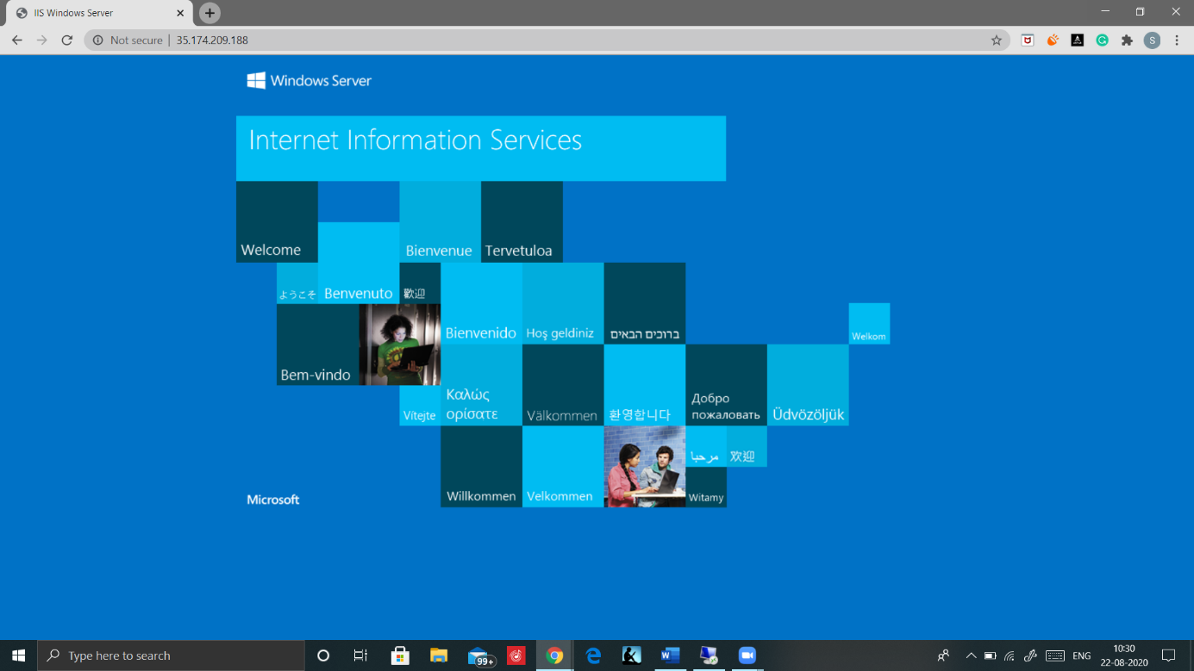

Installation of IIS web server will create a new Directory in your root drive “inetpub”

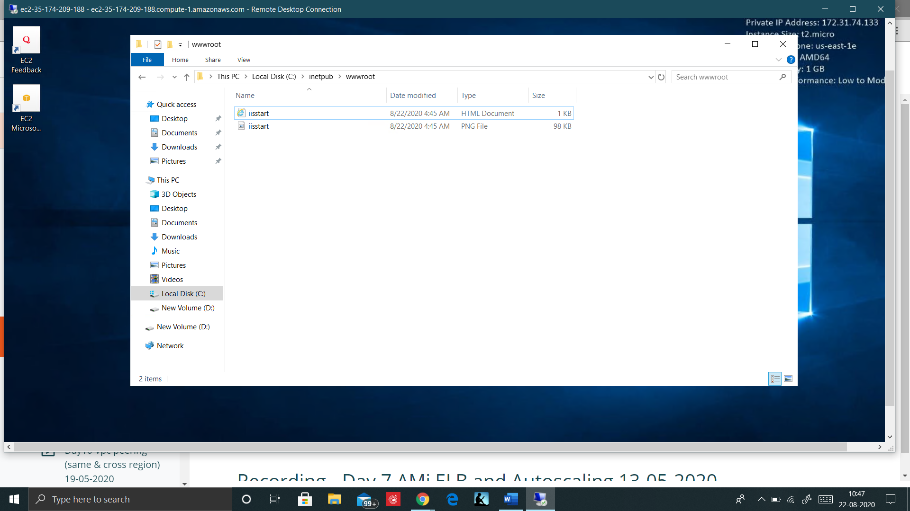

## Creation of AMI

Note Before creating an Image of Windows Instance we need to change the password.

Step1: Open Computer Management, click on Local users and groups, click Users and Set Password for Administrator.

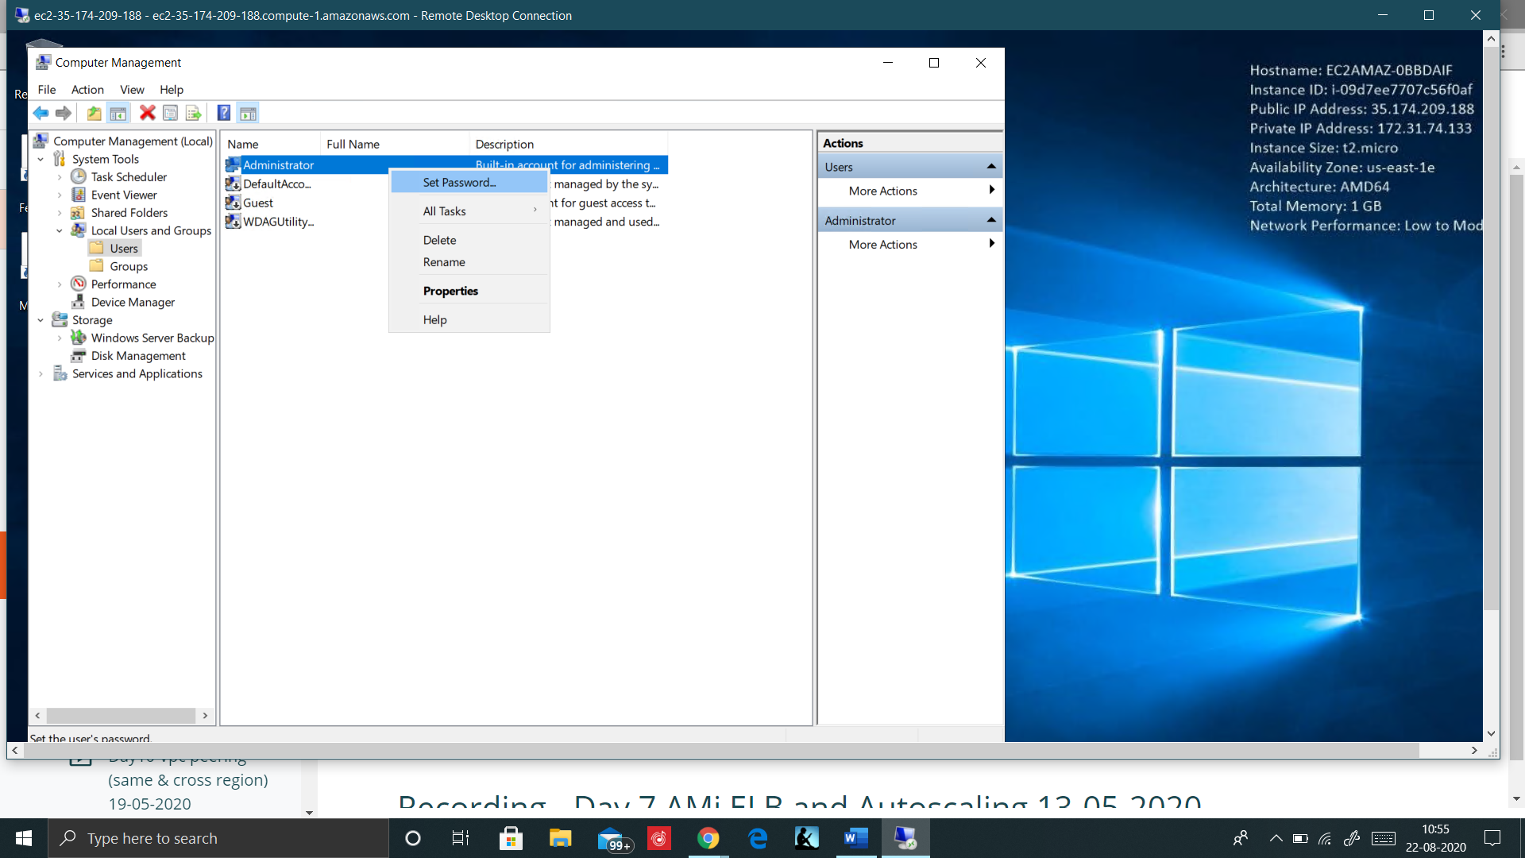

Step2: Open EC2 console, select your Instance and click on actions, then choose image and select create Image.

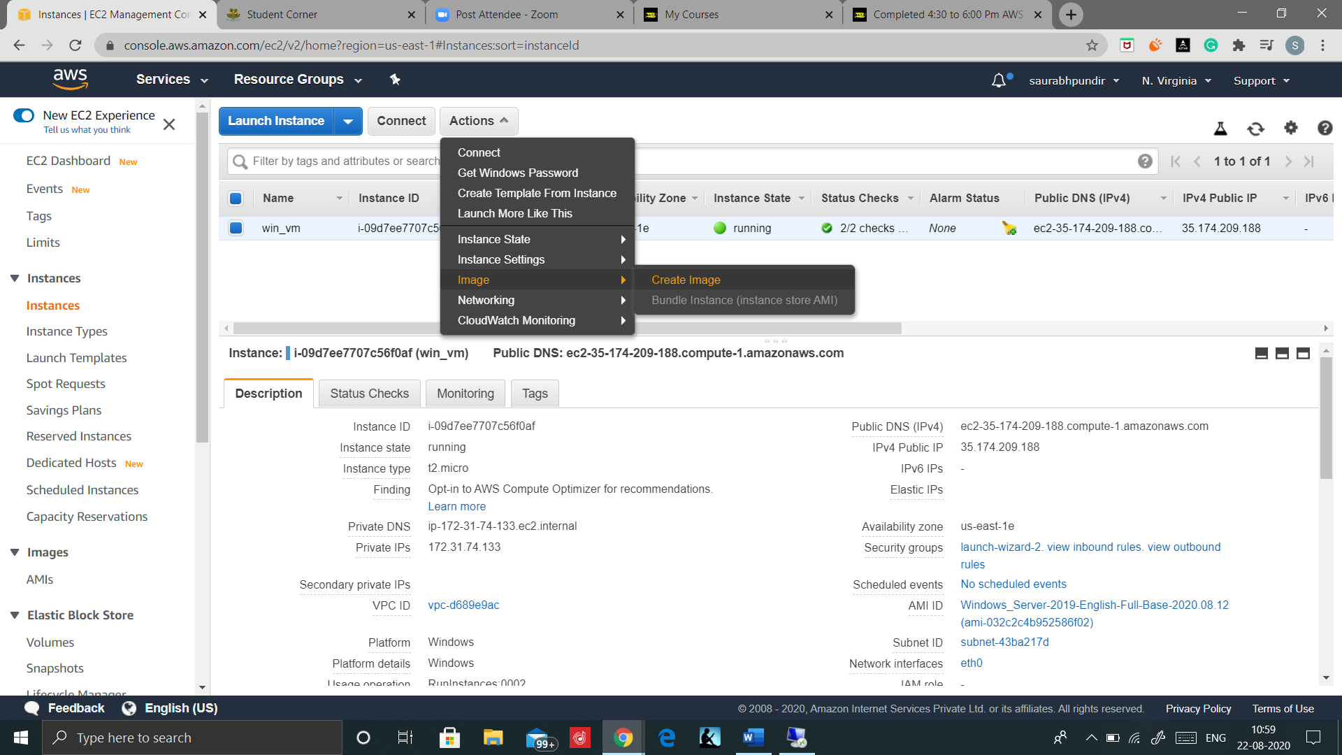

Step3: Now create Image of your Customized windows Instance

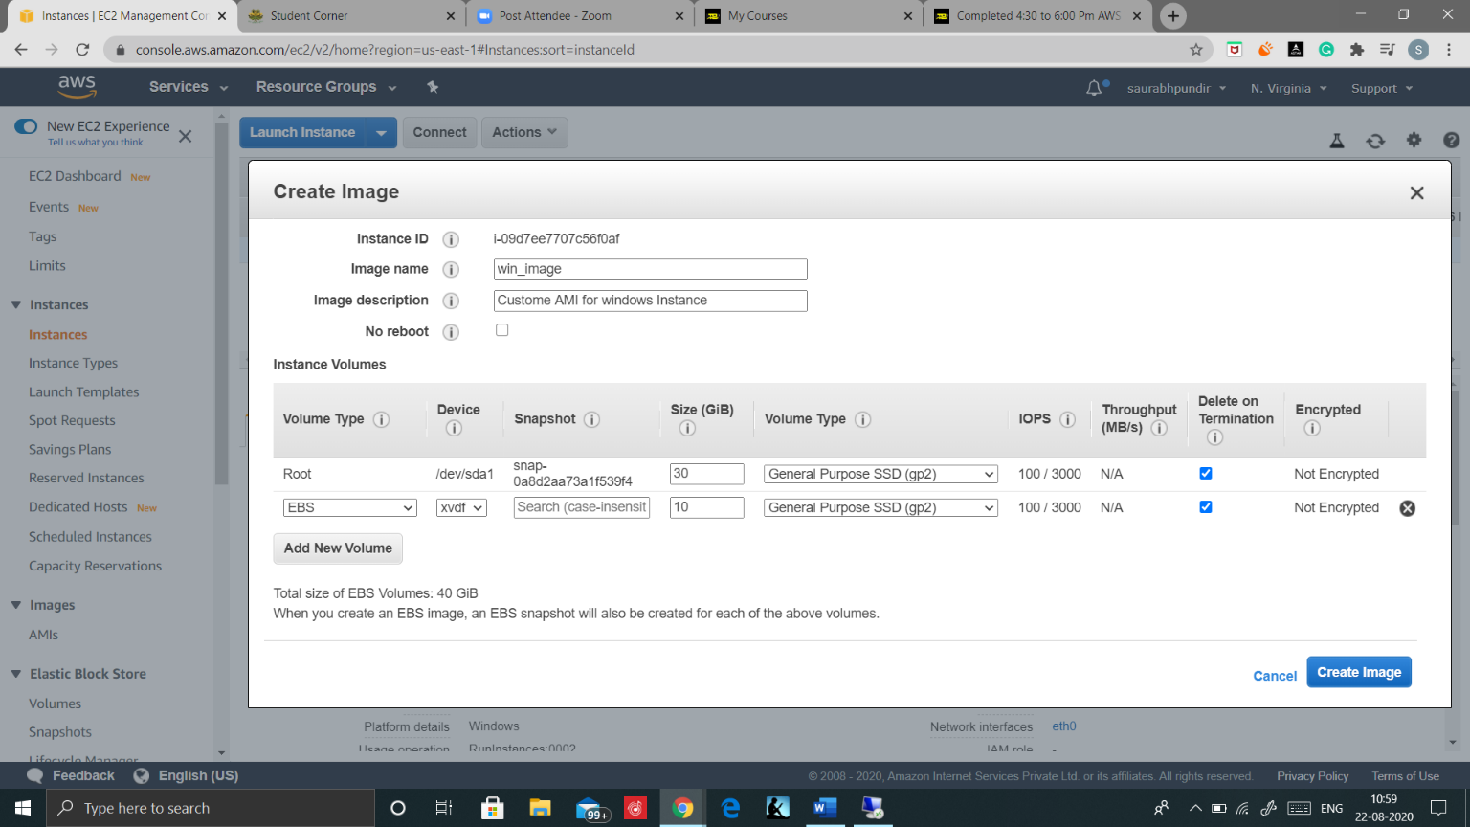

Step4: When AMI is created and in available state so terminate your Instance.

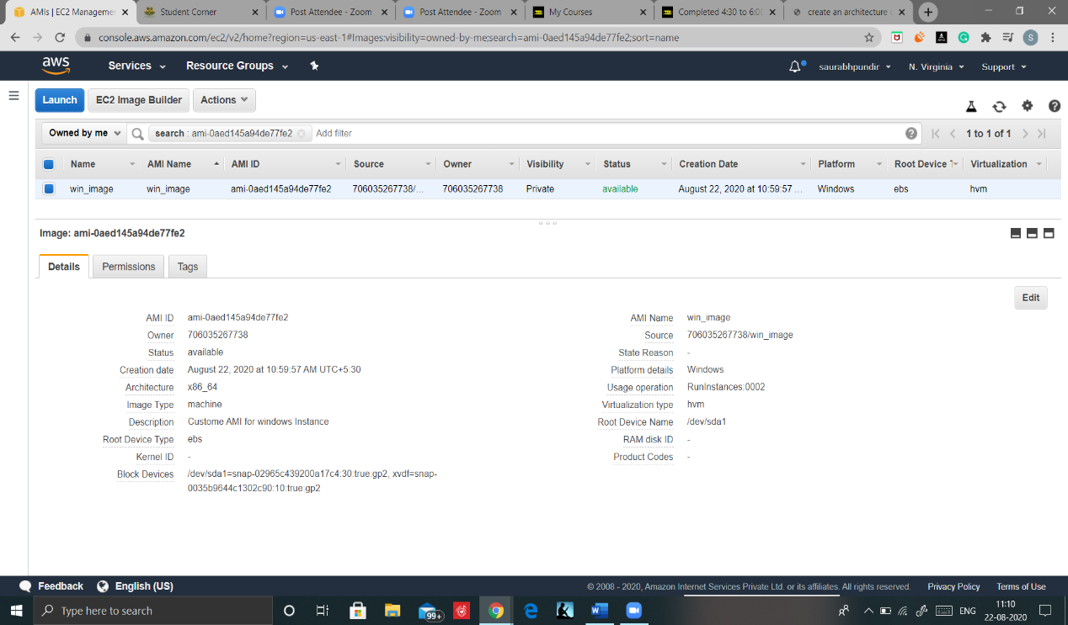

## Creation of Load Balancer

Step1: Open the Load Balancer console and click on create Load Balancer

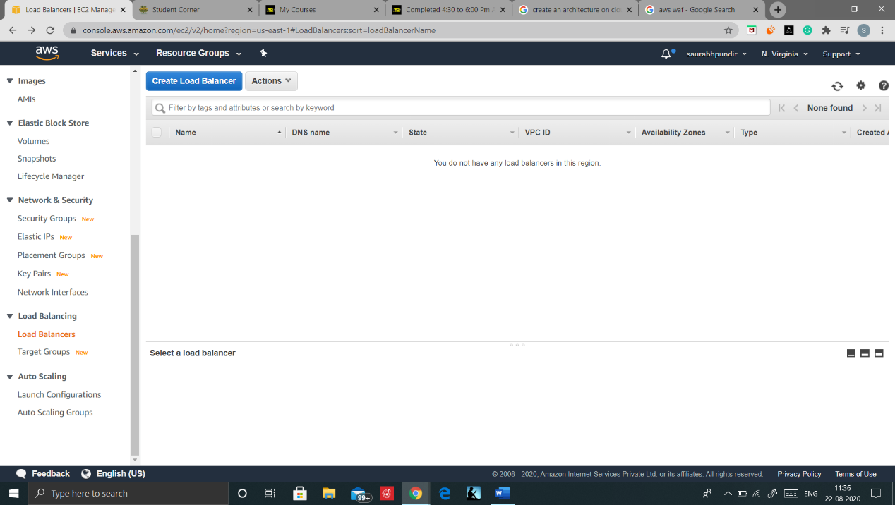

Step2: Select Application Load Balancer as Load Balancer type.

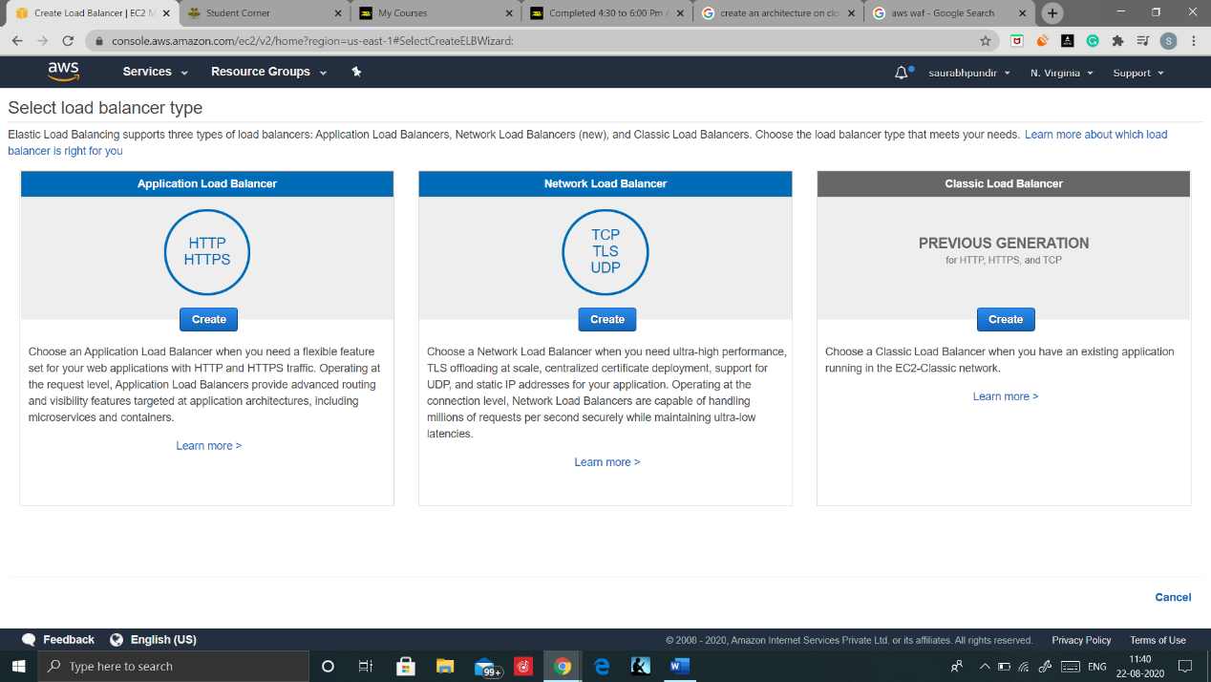

Step3: Configure your Load Balancer as shown below and proceed

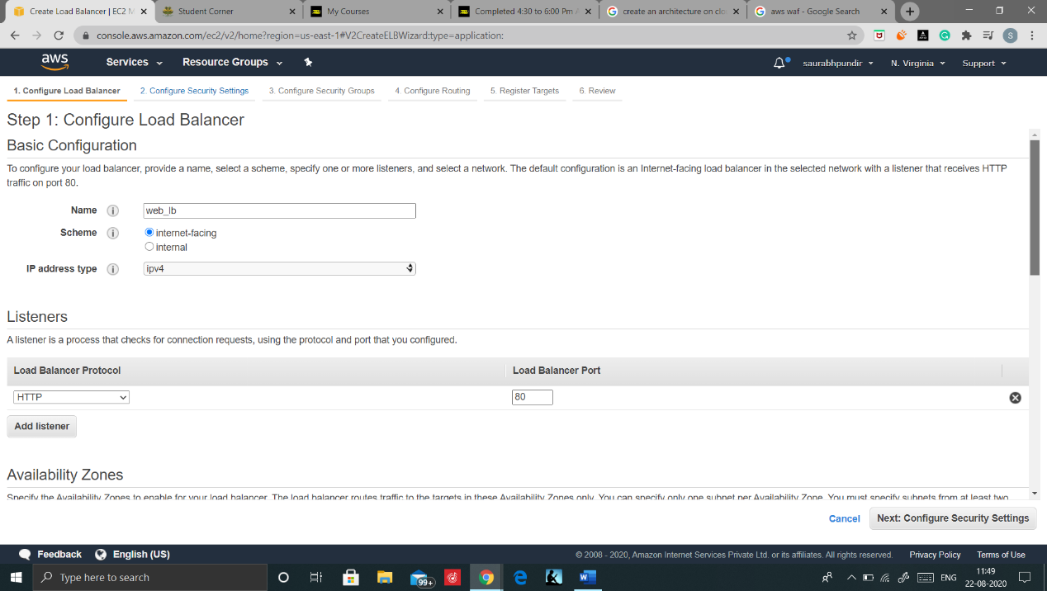

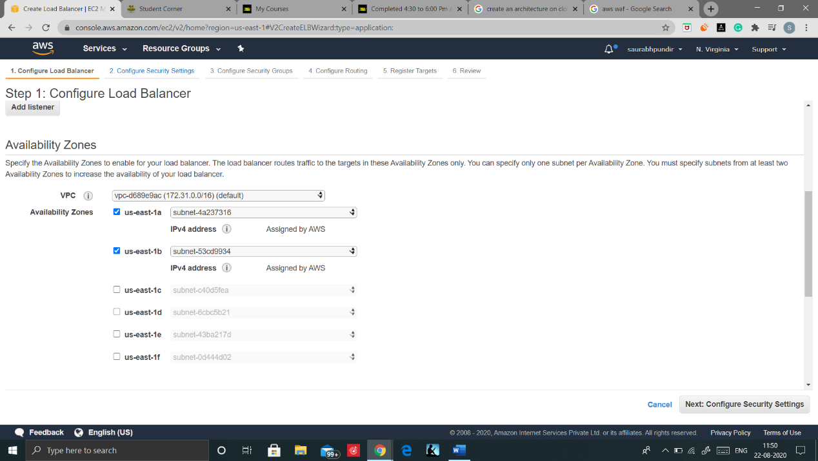

Step4: Create a new security group and add RDP and HTTP rule.

Note Same security group must be used in auto scaling so provide it a suitable name to search it easily later.

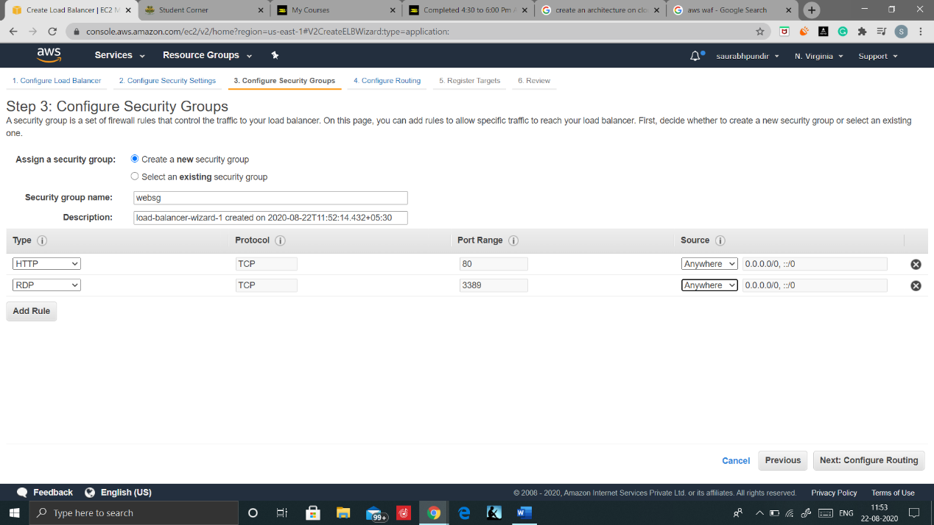

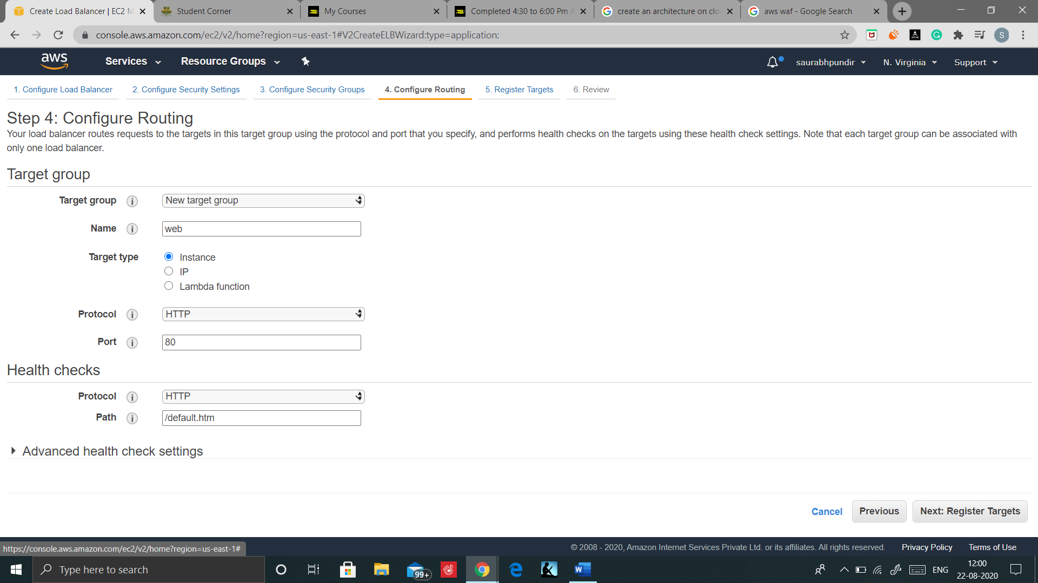

Step5: Configure routing and define the path and name

Now proceed, review and click on create

Your Load balancer is now created, is in Provisioned state and it will take some time to be in active state.

Your Load Balancer is now ready to use and DNS name will be URL that is to be shared to access the application.

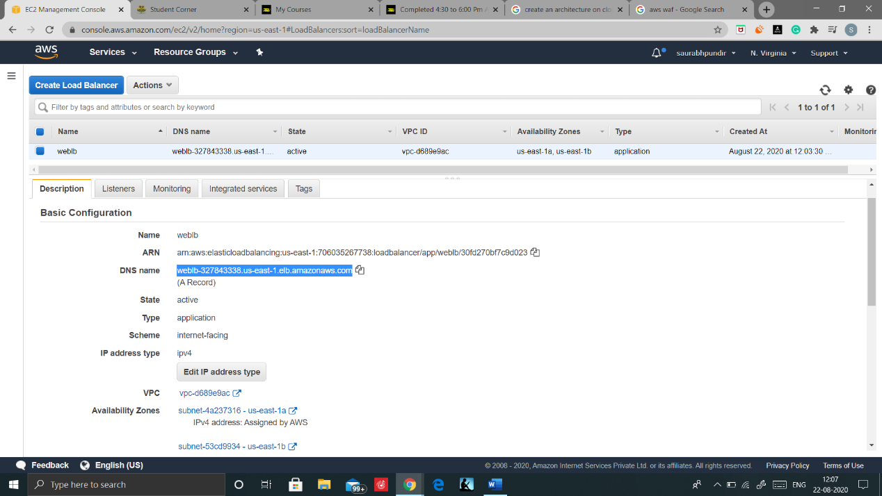

## Create Auto Scaling

Open the EC2 console and click on Auto Scaling group and click on create Auto Scaling Group. Now it will display the two steps that we need to follow during the creation of auto scaling.

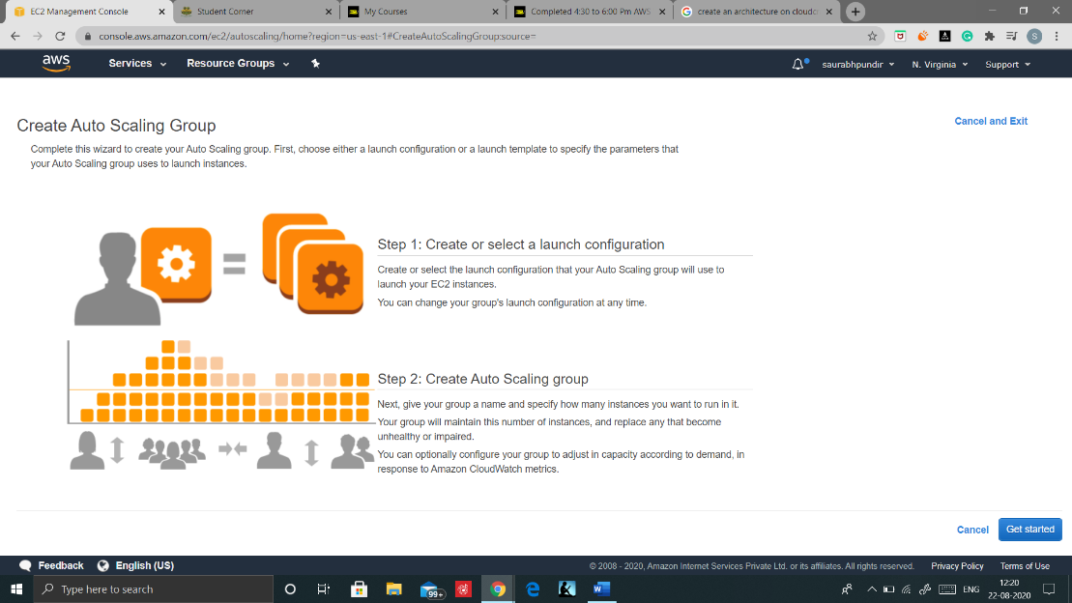

### Create or select a Launch Configuration

Step1: Choose your created customized AMI

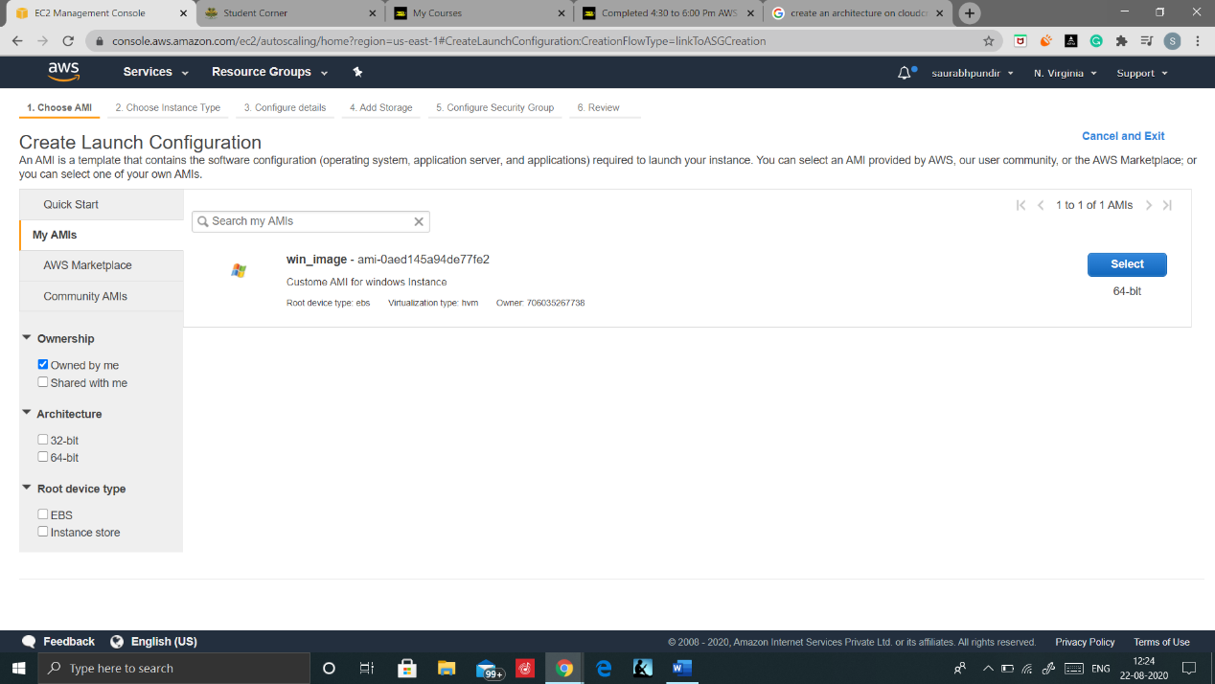

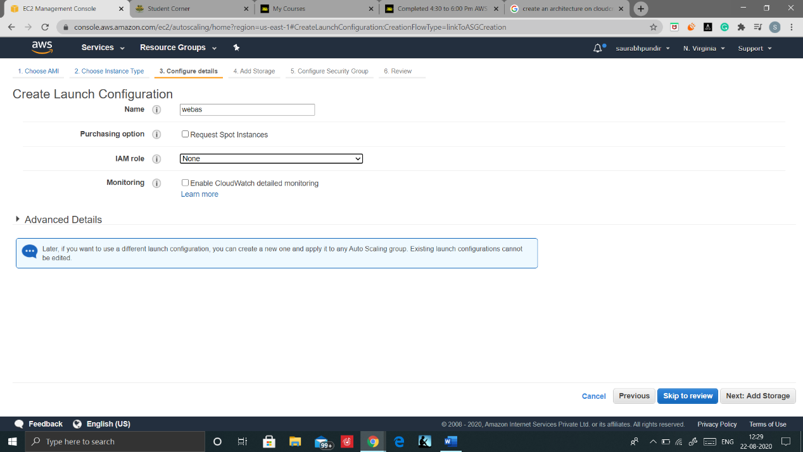

Step2: select t2.micro and click on configure details

Click on Add storage(leave as default) and cick on next

Step3: Configure SG’s and select the Same security group used in Load balancer

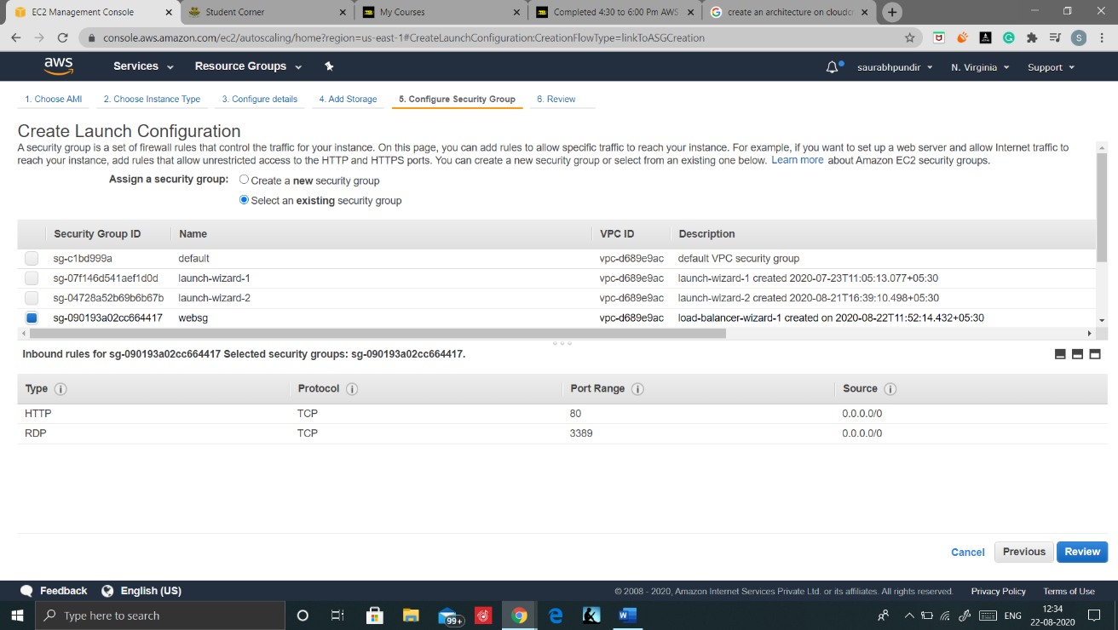

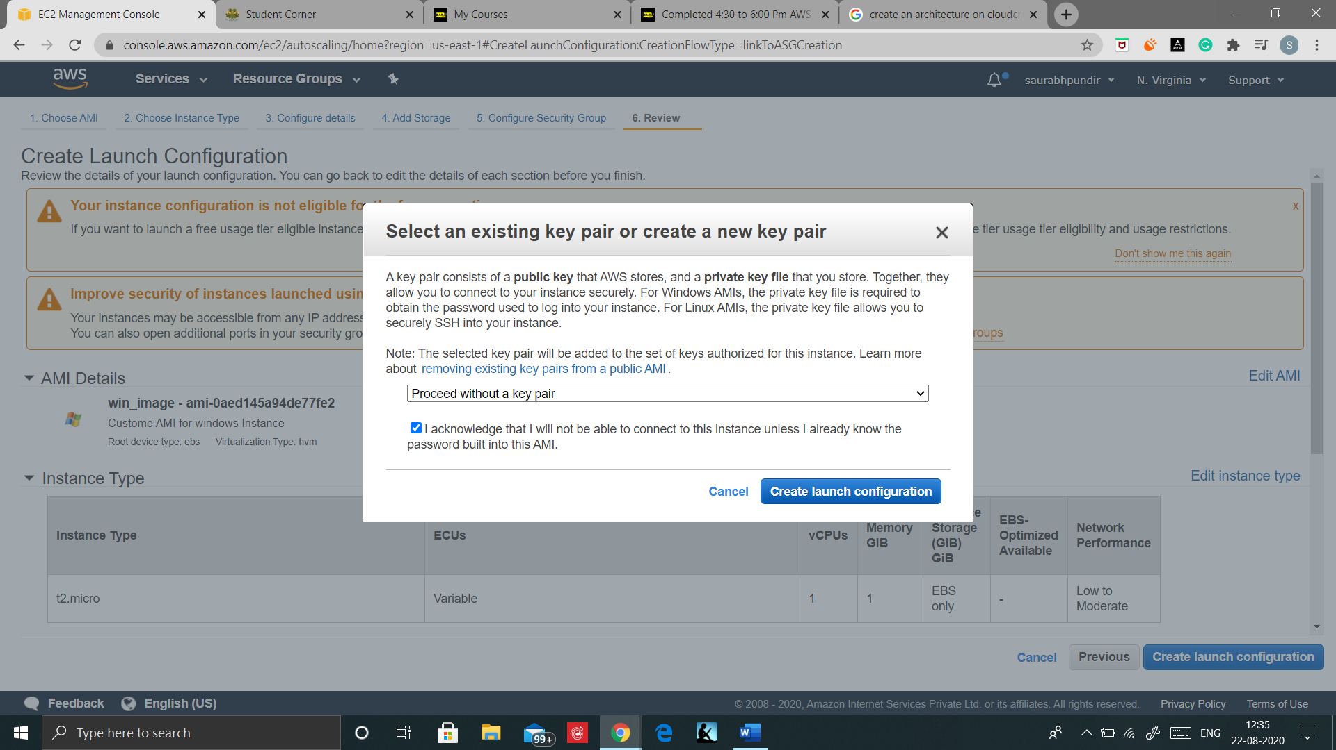

Step4: Review and while launching Proceed without a key pair

And procced

### Create Auto Scaling Group

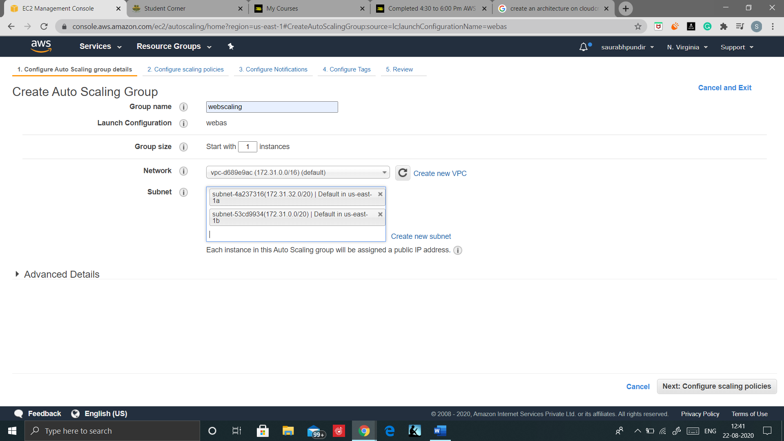

Step1: Configure Auto Scaling Group details.

And Click on advance details

Step2: Configure Advance Details and click on Next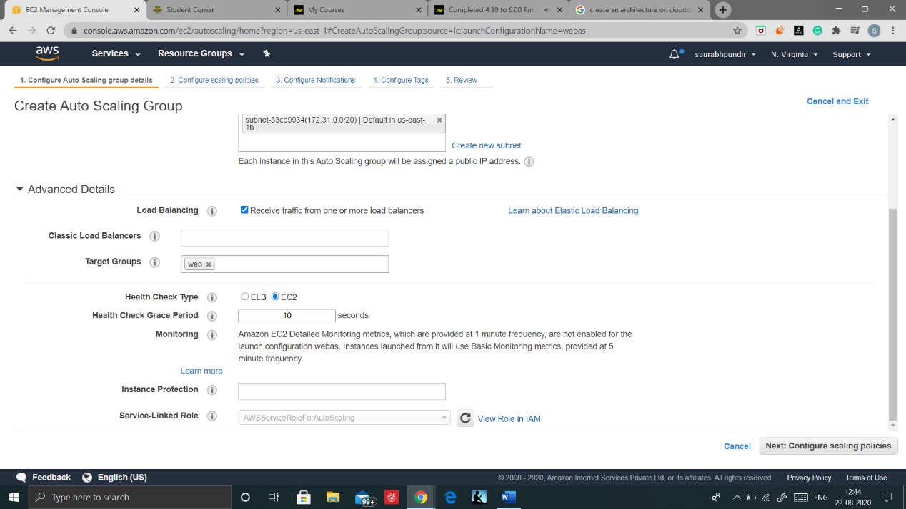

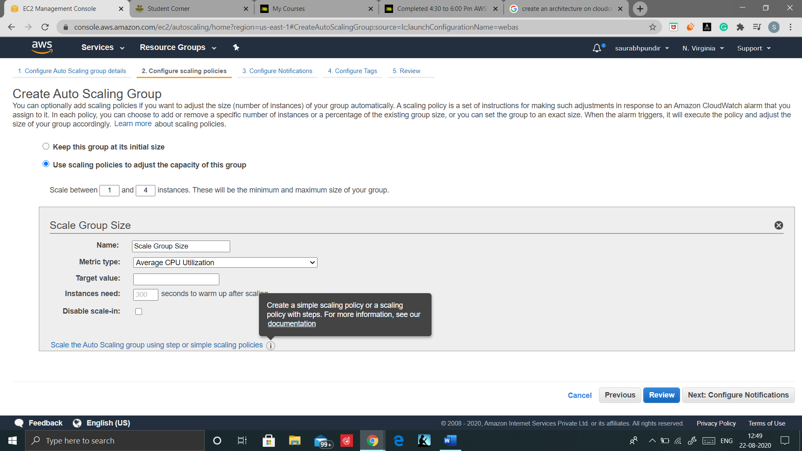

Step3: Adjust the group capacity as per your requiremt

And Click on below link.

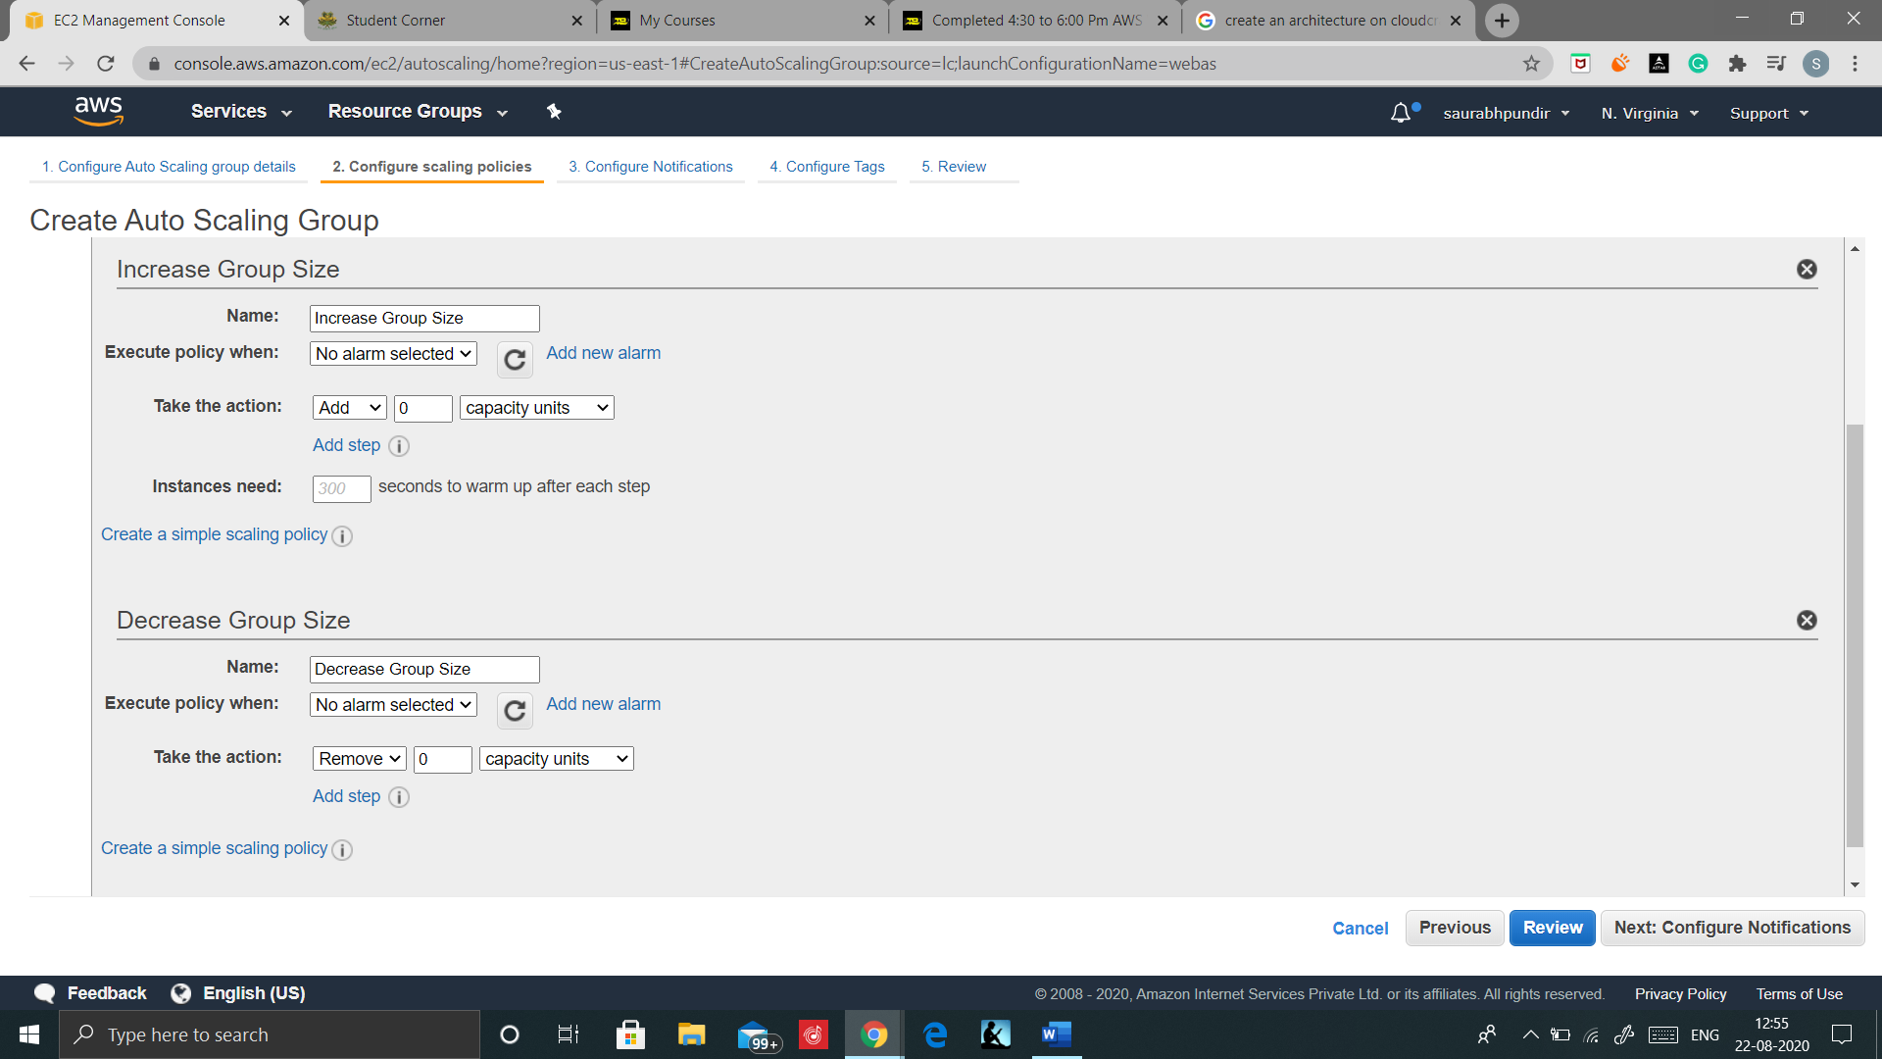

Step4: click on Add new Alarm

And create a New alarm

Do the same with decrease group size.

Now proceed review and launch

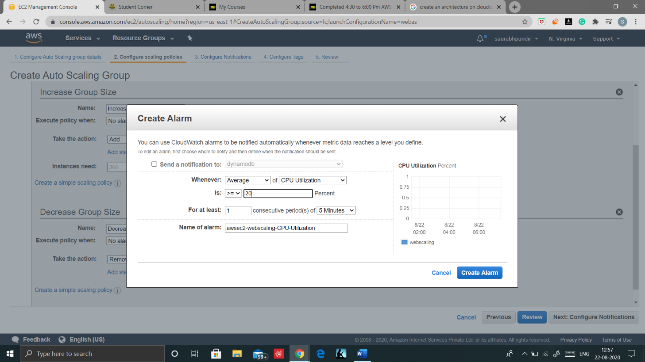

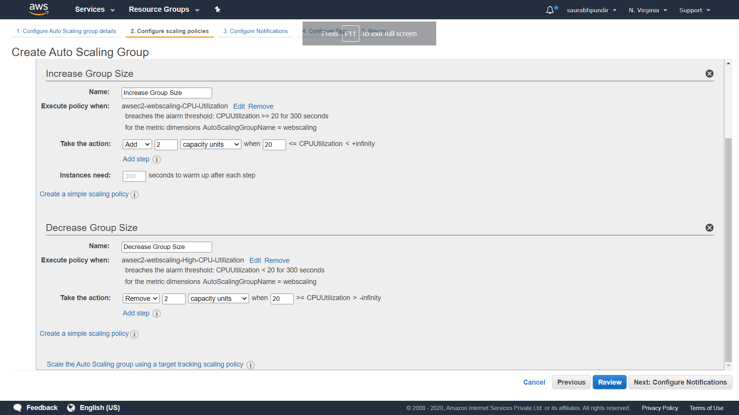

Your Auto Scaling is now Configured.

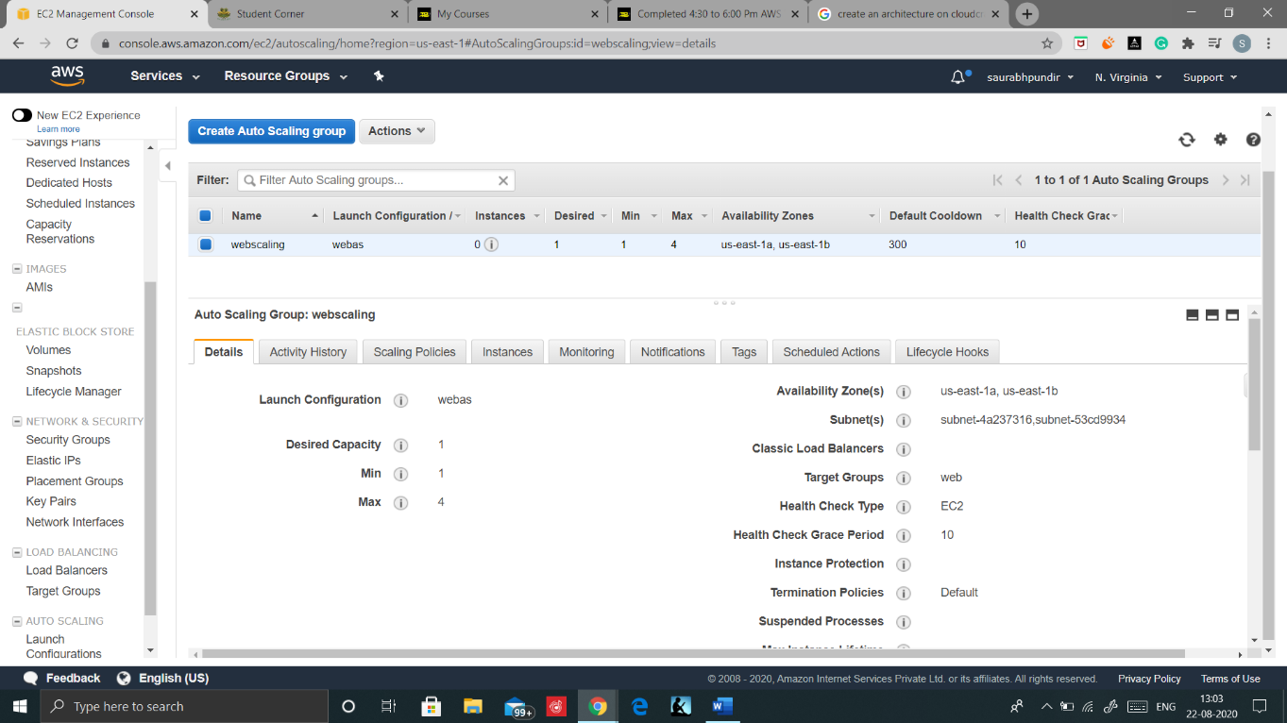

# TESTING

Step1: As soon as Auto scaling is launched It will launch the minimum instance i.e. 1

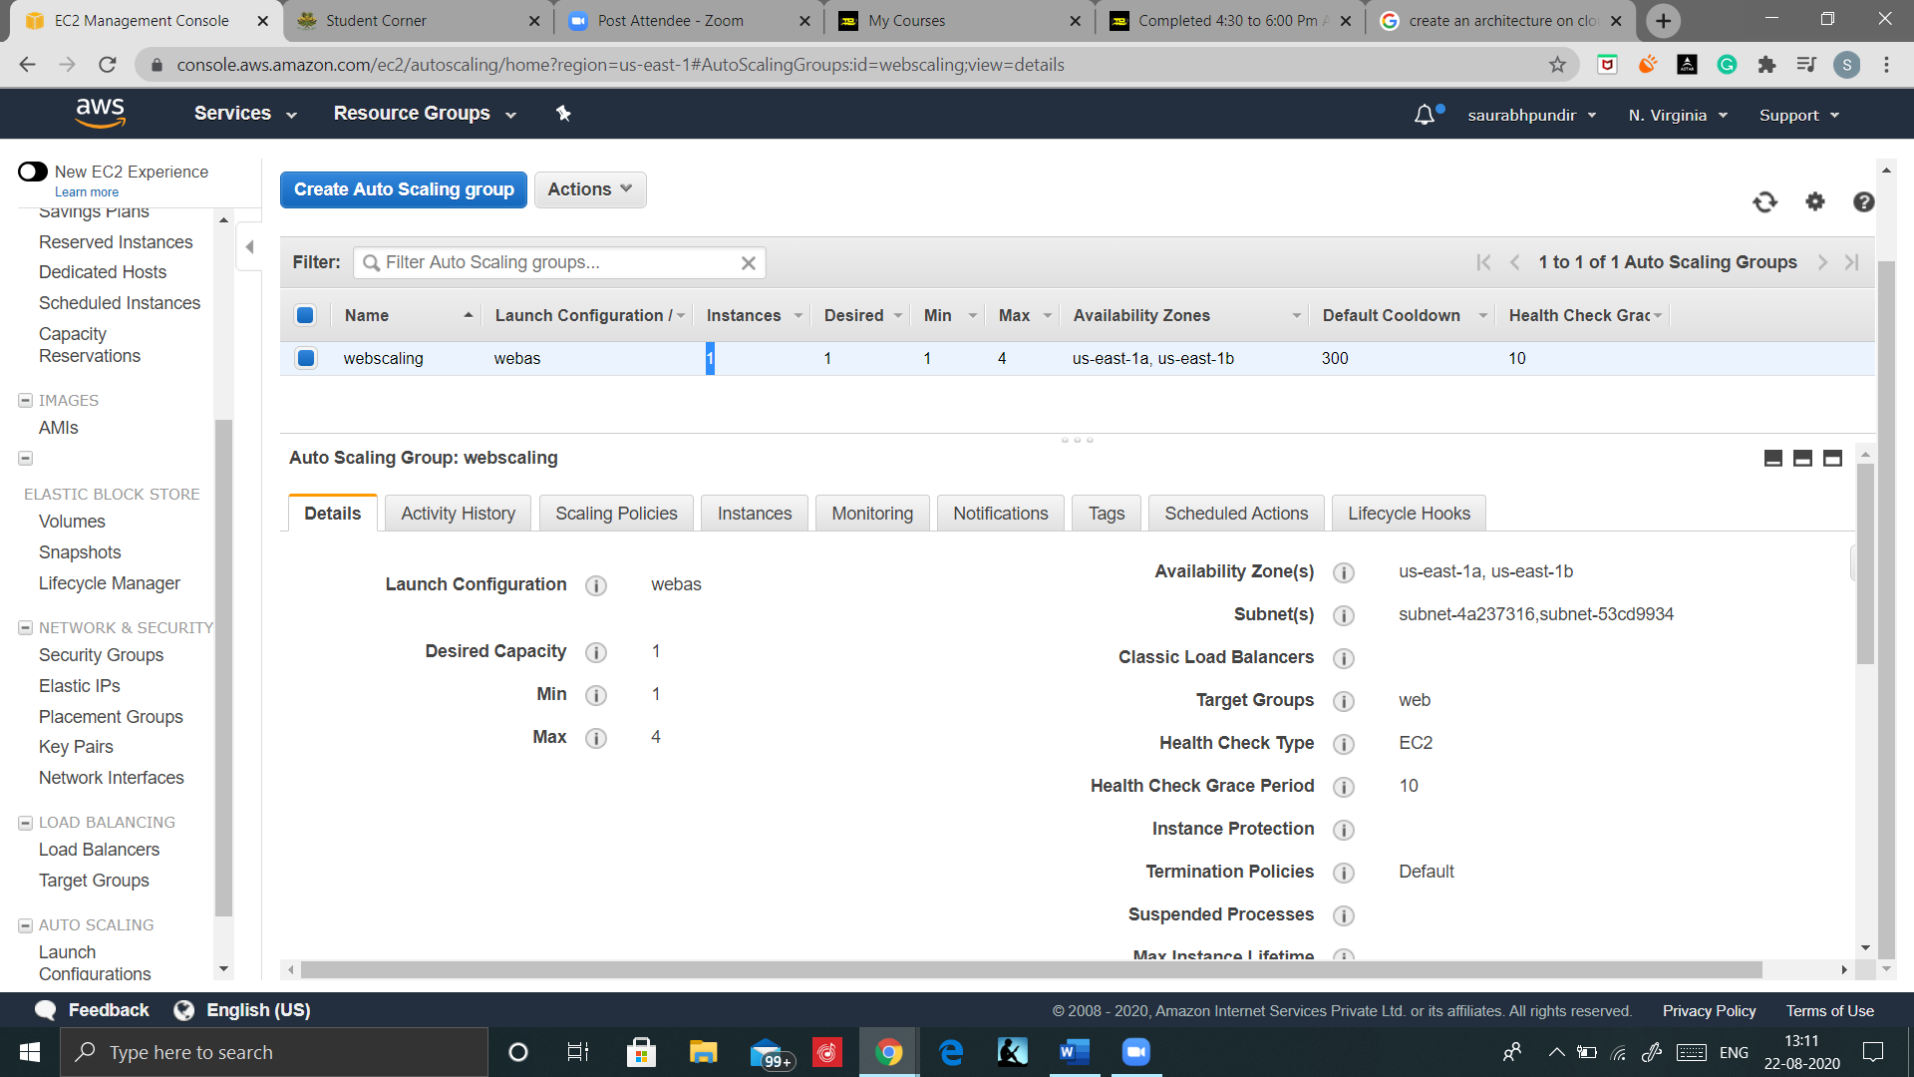And we can check in your ec2 instances also

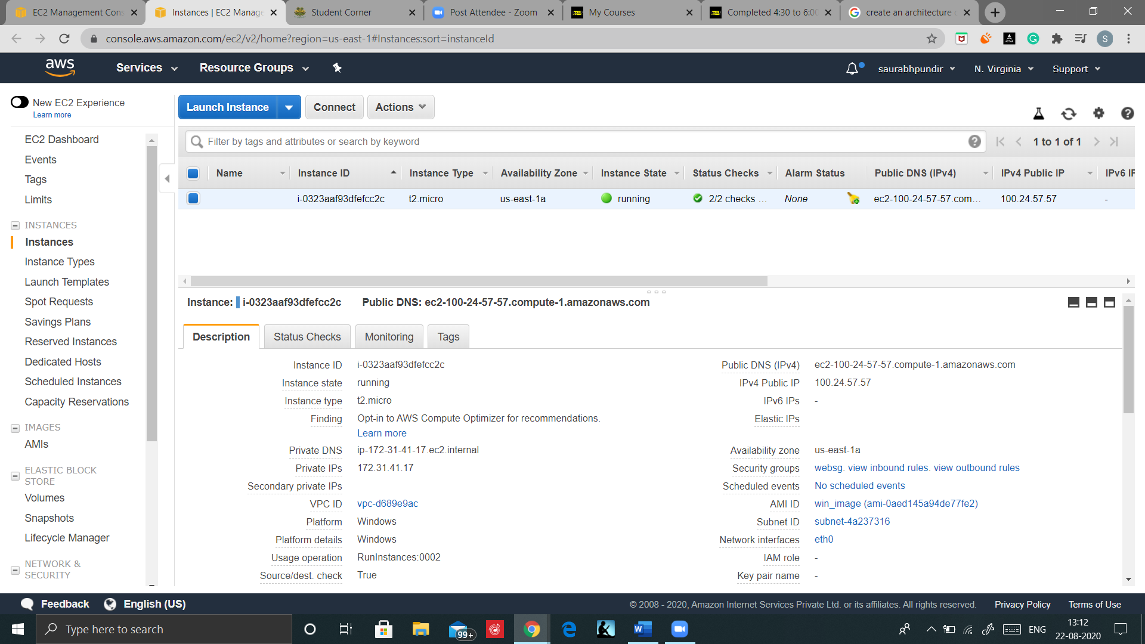

Step2: Open the Load Balancer console and copy the DNS.

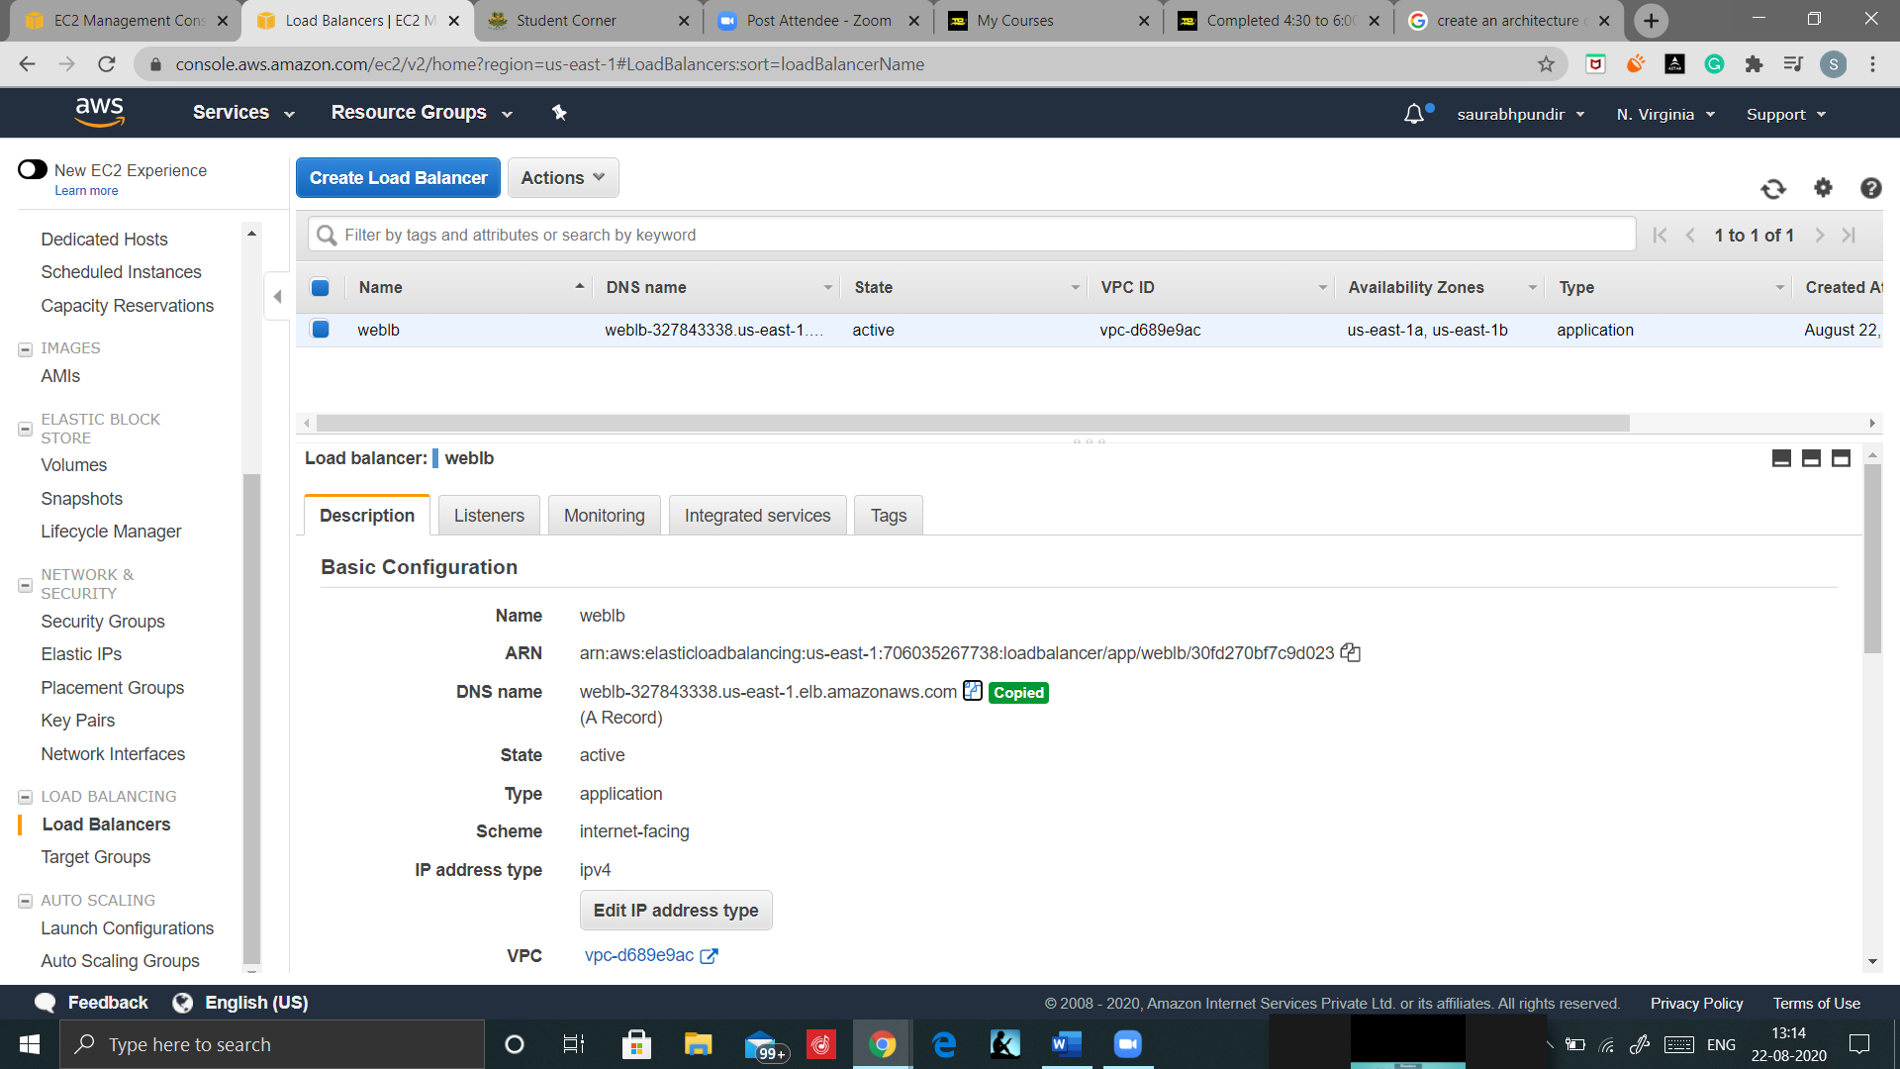

Step3: Open Ec2 Console and connect to the instance by downloading Remote Desktop File and using the password that we have changed previously for the instance.

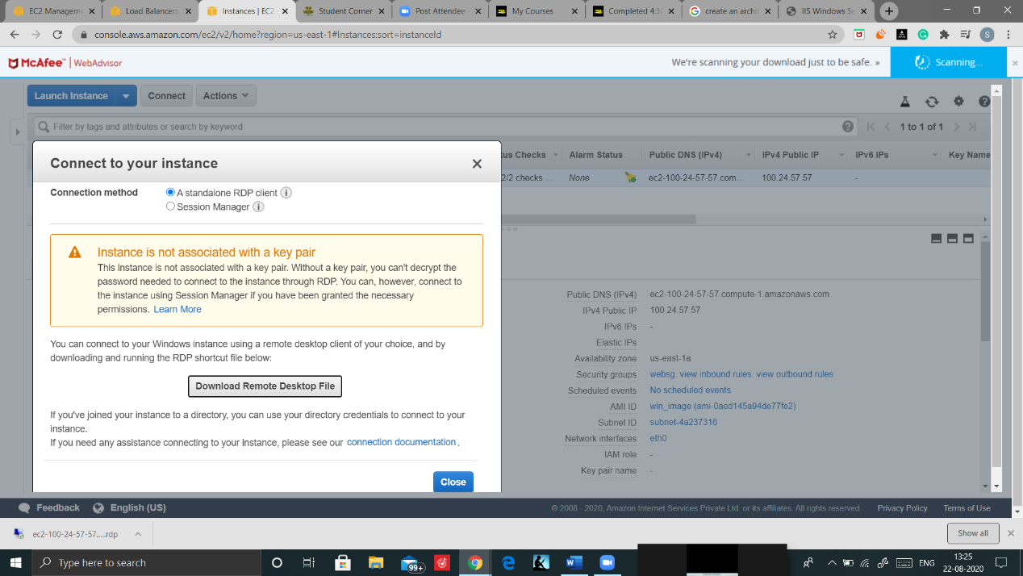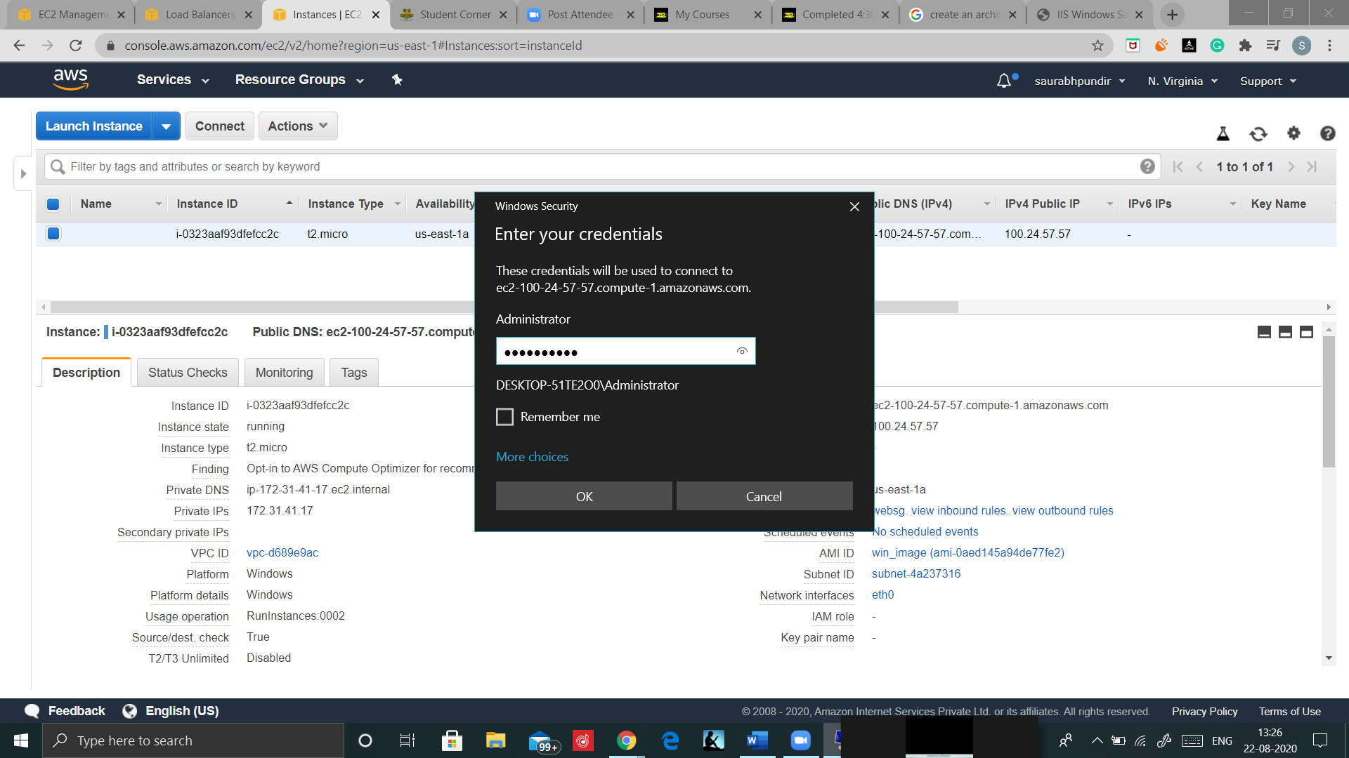

And as you can see that we have access to EBS disk and inetpub directory is already installed in root drive. Everything that has done of configured in the AMI or instance are intact here.

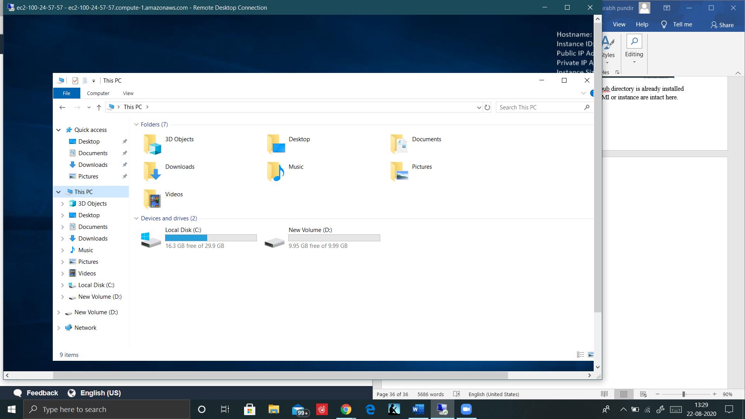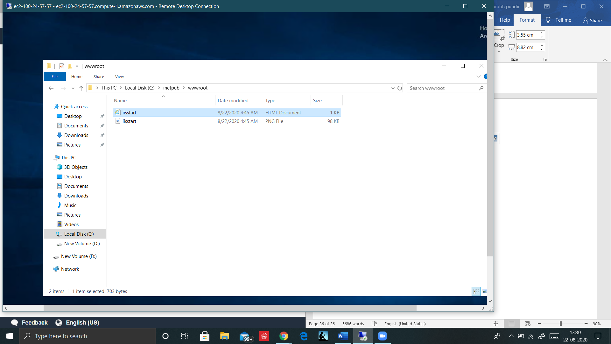

Step4: As Inetpub is already installed so paste the copied DNS and we are directed to the windows IIS web server home page

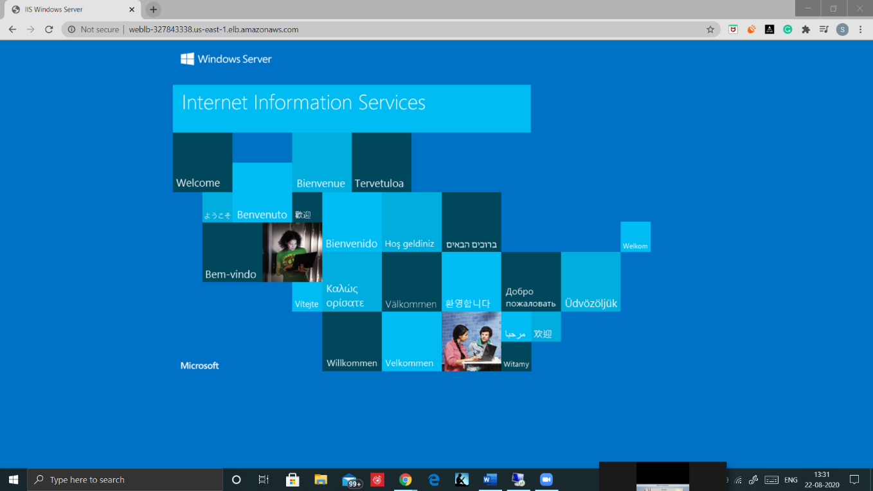

Step5: Now as we Increase the number of hits on this DNS the number of desired instances will increase automatically hence scaling up the resources

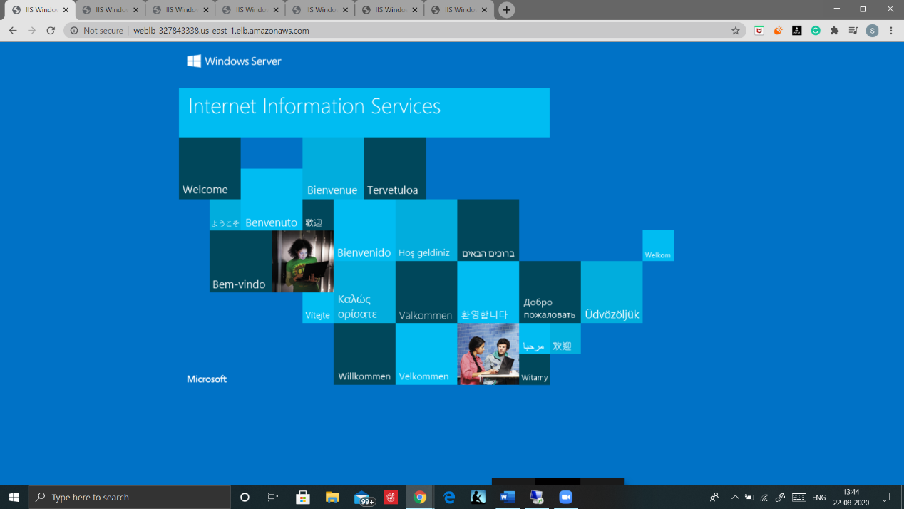

The number of Instances is now increased, hence Scaling up is Successful

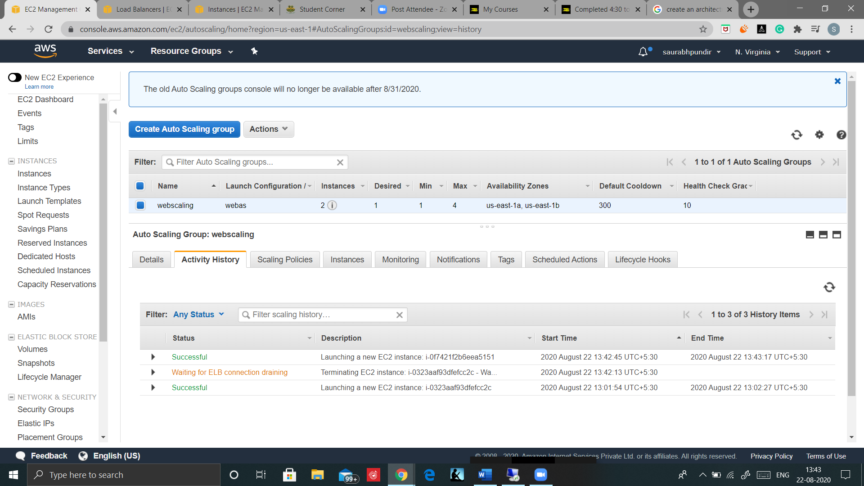

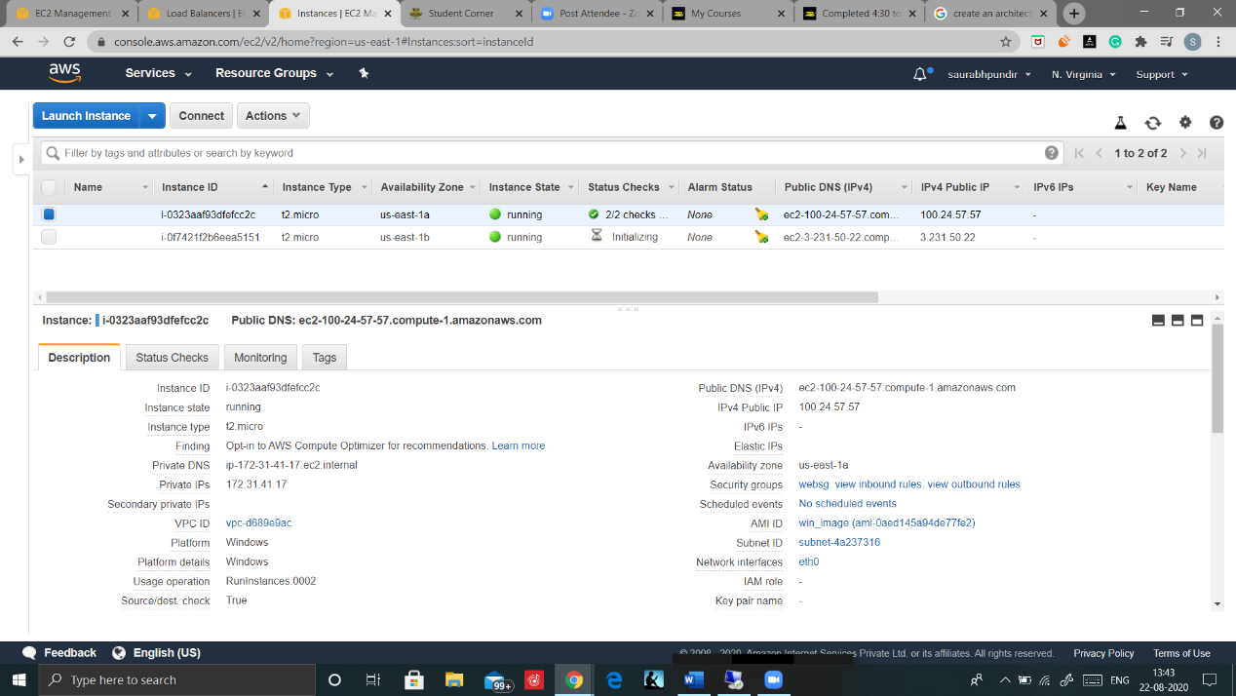

Step6: Now close some tabs to reduce the number of traffic

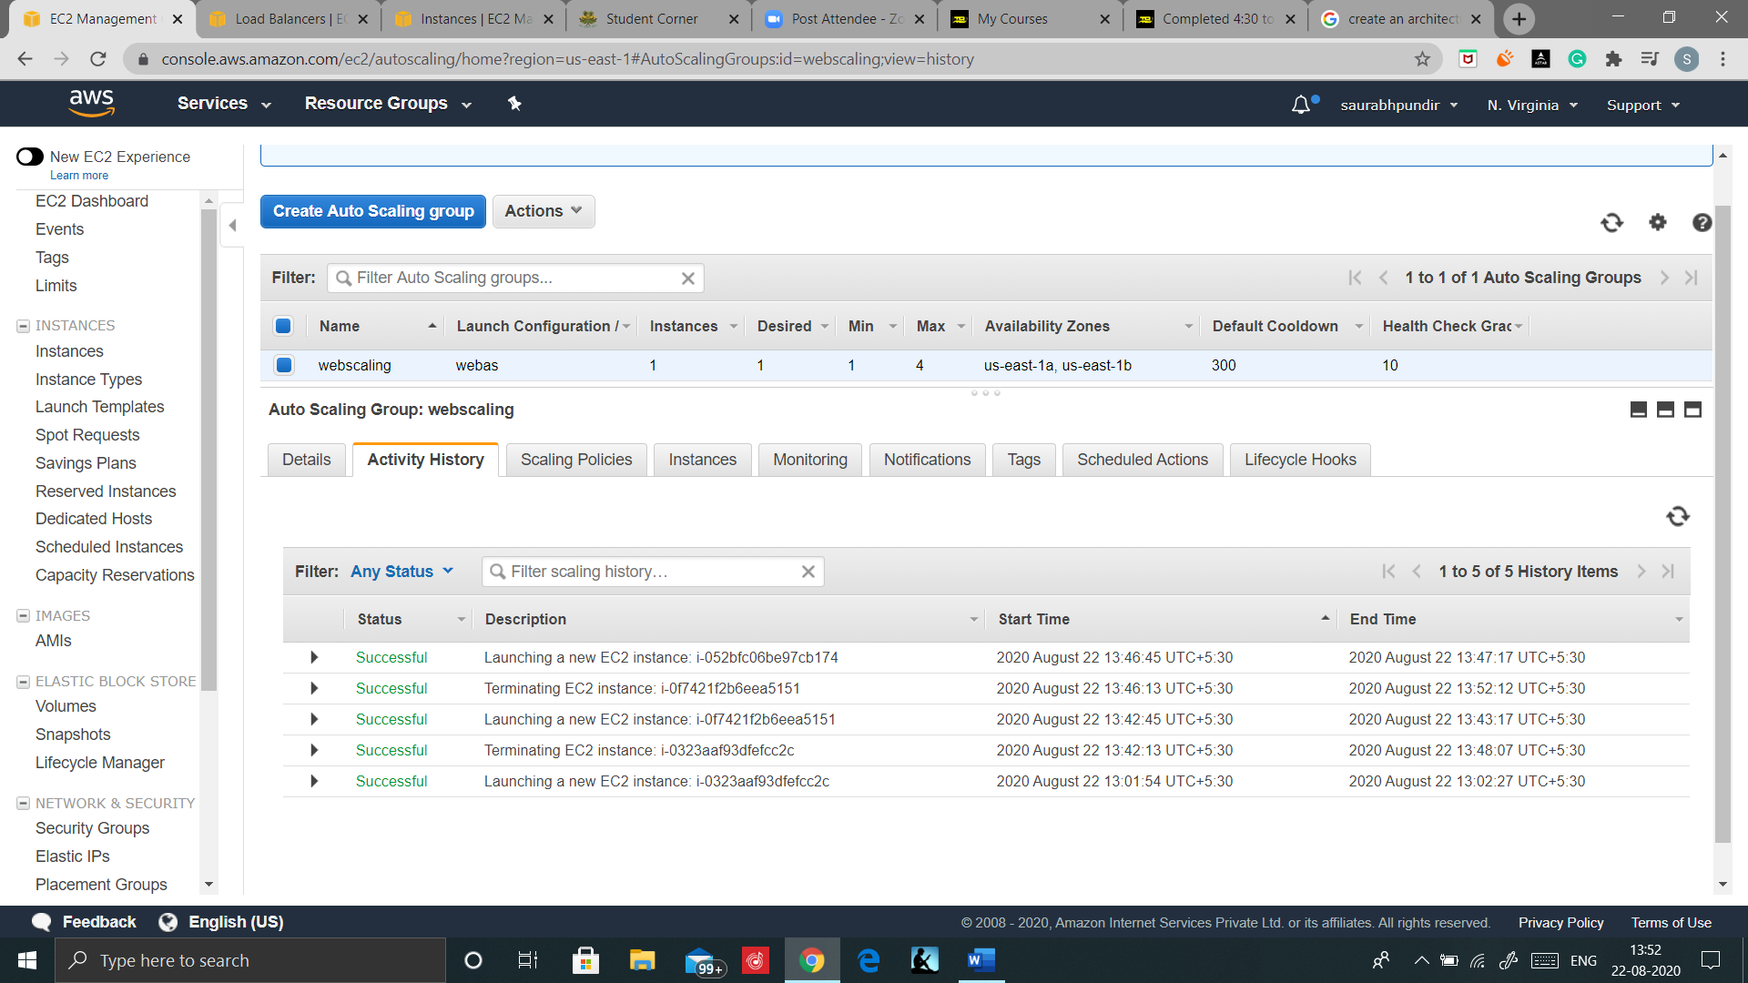

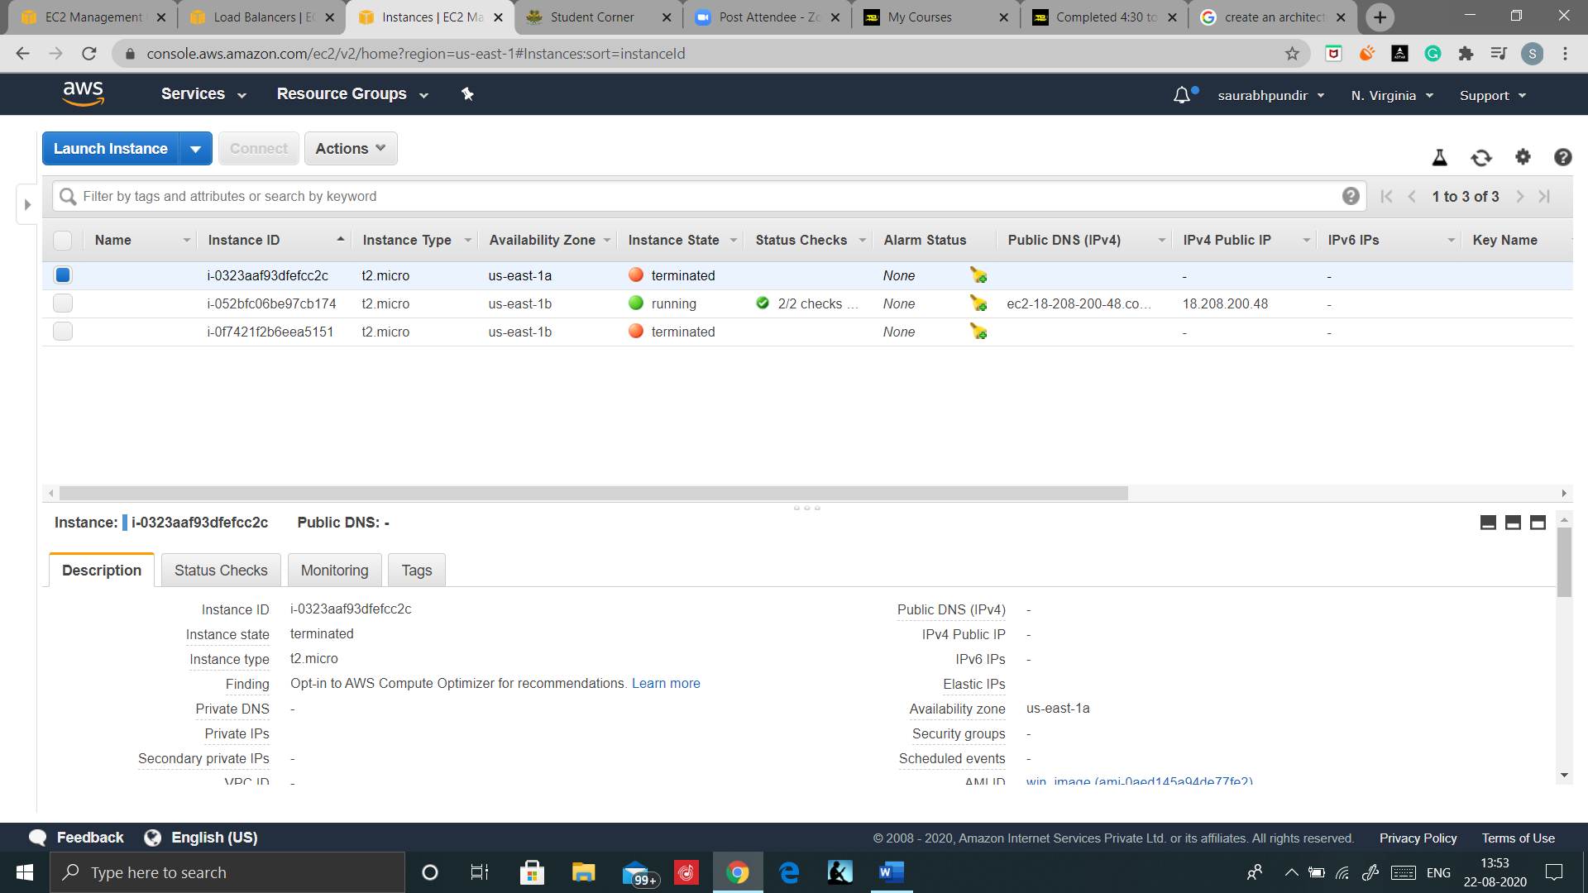

Number of running Instances are now decreased, Scaling Down is successful.

Hence AUTO SCALING is working fine.

# TERMINATING THE ENVIRONMENT

Step1: Terminate your Auto scaling. Select your auto scaling group and click on actions then select delete. Your Instances will automatically terminated after some time.

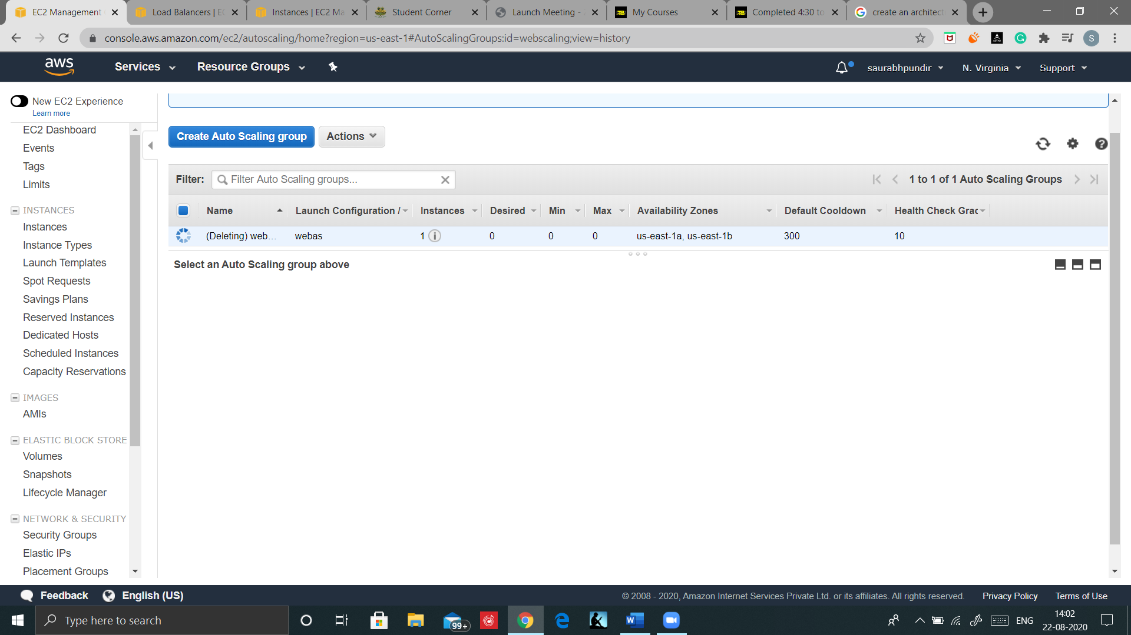

Step2: Deregister the AMI, Select your Ami click on Actions and then select deregister

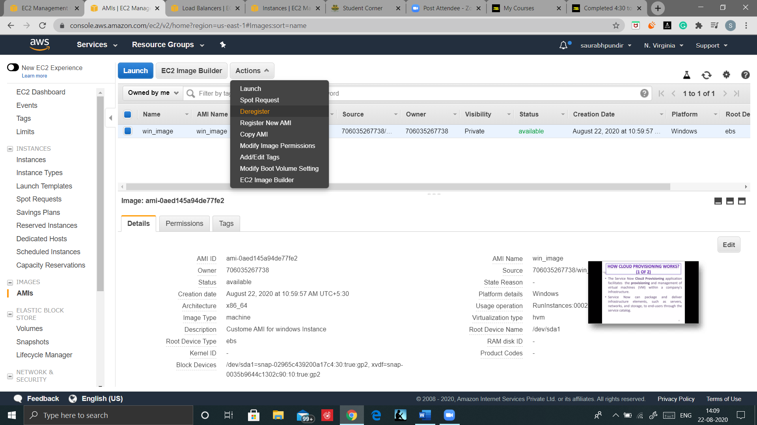

Step3: Delete EBS volume, Select your EBS disk click on actions and select Delete Volume

Steo4: Delete the Snapshots.

Step5: Delete the Load Balancer and target Groups

Step6: Delete the Launch Configuration in Auto Scaling

Now check for any running Running resources in EC2 Dashboard. And terminate if any.

